Science: Living Things and their habitats

- Explore the conditions for life and differences between living and non-living things
- Group organisms based on their characteristics
- Classify animals and plants
- Explore and classify microorganisms
- Know about the work of Carl Linnaeus and his system of classifying organisms
- Use and develop keys and other information records to identify, classify and describe living things
Maths
Place Value
- Read and write numbers to 10,000,000
- Powers of 10
- Compare and order any integers
- Round any integer
-Negative numbers

Four Operations
Add and subtract integers Step 2 Common factors
Common multiples
Rules of divisibility
Primes to 100, Square and cube numbers
Multiply up to a 4-digit number by a 2-digit number
Solve problems with multiplication
Short division and long division
Division with remainders
Solve multi-step problems
Order of operations
Mental calculations and estimation

History: World War 2

- To find out what World War 2 was and where and when it took place.
- To find out what the Blitz was and which areas were most likely to be affected.
- To learn about the effects of air raids and the causes of evacuation.
- To find out about the experiences and feelings of evacuees.
- To find out what rationing was, why it was necessary and how it impacted on people’s lives.
- To learn about the experiences of Jewish children during the war and that the war created many refugees.
- To consider how the war affected people’s everyday lives.

Computing: Bletchley Park and the history of computers
- To understand there are many different types of secret codes
- To understand the importance of having a secure password
- To recognise the importance of the history of computers and create a well-researched presentation
- To design a computer of the future
- To create an audio advert for a future computer


French: French sport and the Olympics

- To express playing a sport using the correct verb and preposition
- To express sporting preferences using an opinion verb, a second verb and an adjective
- To express travel plans using the verb ‘aller’
- To create sentences for a sports diary including opinion verbs, second verbs and adjectives
- To create a description using familiar language, a wide range of vocabulary and grammatical structures

Year 6
Autumn 1
This term our topic is on:
World War 2

Music: Dynamics, pitch and texture (Fingal’s cave)
- To explore and appraise the work of a classical composer (Felix Mendelssohn – Fingal’s cave)
- To improvise as a group using dynamics and pitch
- To improvise as a group using texture
- To use knowledge of dynamics, texture and pitch to create a group composition
- To use teamwork to create a group composition featuring changes in texture, dynamics and pitch



PSHE: 1 Decision
Emotions and Feelings

- Recognise our thoughts, feelings, and emotions, and identify the differences between those that feel good and those that feel not so good
- Describe how we can support others who feel lonely, jealous, or upset
- Recognise that we can choose how we act on our emotions and understand that our choices and actions can affect ourselves and other people
- Demonstrate a range of strategies to help control and manage unpleasant/ uncomfortable emotions, such as loneliness and jealousy

R.E: Islam Part 1
Theme: Beliefs and Practices
Key Question: What is the best way for a Muslim to show commitment to God?
Religion: Islam
- Explore commitment and what it means to show commitment in Islam
- Recap prior learning on the 5 pillars of Islam and recognise and investigate commitment around the following pillars: Salah, Sawm and Hajj.
- Evaluate how commitment can be difficult to follow through but how Muslims find opportunities to show commitment
- Express how one is committed to something and explain why it is important to them
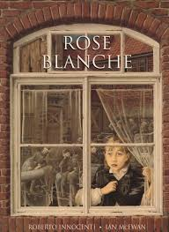
English

Writing outcomes
- Diary entry
- Bravery award speech

-Grammar word: Informal and formal speech; synonyms and antonyms.
-Grammar sentence: Informal and formal speech; passive voice; degrees of possibility using adverbs.
-Grammar text: Linking ideas within and across paragraphs using adverbials.
-Grammar punctuation: Colons to introduce lists; semi-colons within detailed lists and mark boundary between independent clauses; dashes and commas to indicate parenthesis.
Reading
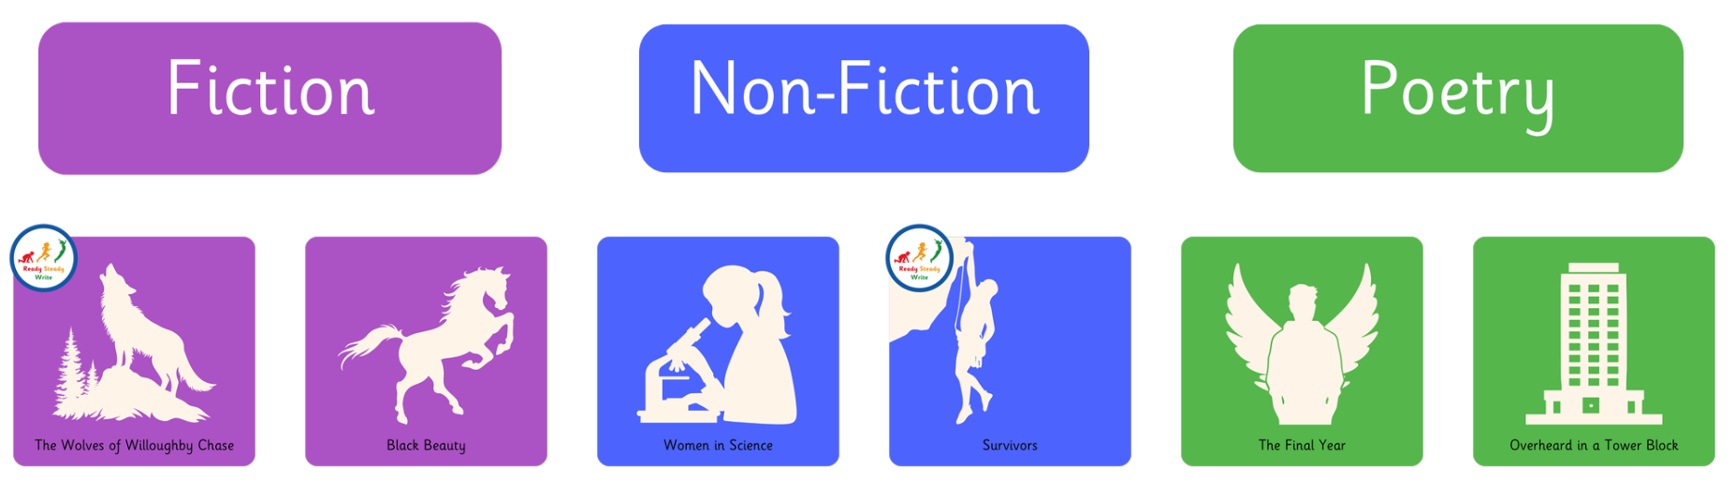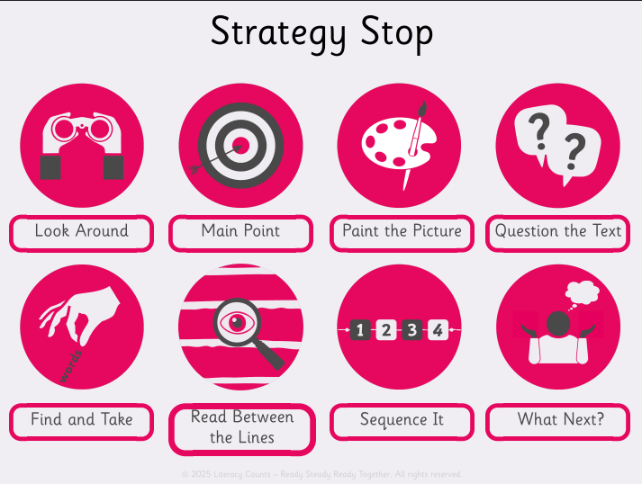

Art
Skill- Collage/textiles
Inspirational Artist-Hannah Hoch
- Focus on inspirational artist, observe artwork and discuss techniques. Explore feelings, thoughts and emotions.
- Explore techniques using inspirations artwork and develop a collage (colours, texture, patterns)
- Critique and up level- Explore techniques using inspirations art work and develop collage with the focus form of media
- Master techniques- Creating their own version taking inspiration from the Artist.
- Evaluate techniques and compare own work with inspirational artist work.

P.E
Games: Invasion – Netball and Health Related Exercise
- Develop understanding of the rules of the game and how they can apply this knowledge to play in mini games
- Understand to defend as soon as we lose possession of the ball
- Apply understanding of attacking and defending tactics to Stinger netball games.
- The focus of the learning is to develop pupils' understanding of aerobic fitness and how exercise affects our bodies.

