Science- Group and classify living things

- Identify and group animals based on their features
- Recognise the difference between vertebrates and invertebrates
- Use simple keys to classify animals
- Sort and group plants in different ways
- Classify plants based on simple physical characteristics
Geography – Worlds Kitchen
Food history and celebration of immigration

- To generate a knowledge harvest of what they already know about “world’s kitchen” and different types of foods.
- Describe the seven continents of the world and the oceans that surround them – using a world map / Atlas.
- To identify and plot coordinates. Identifying regions of the world and the foods traditionally found there.
- Identify traditional foods belonging to the continents of the world.
- Explain why specific foods identified may be traditionally served within these countries.
- Identify traditional foods belonging to the continents of the world. Explaining why specific foods identified may be traditionally served within these countries.
- Explain the social and ethnic changes that have happened over time in British History
- To describe and understand key aspects human geography – Fair trade.

Maths
Place Value
- Number line to 10,000
- Estimate on a number line to 10,000
- Compare numbers to 10,000
- Order numbers to 10,000
- Roman Numerals
- Round to the nearest 10, 100 and 1000 (Separate lessons and then one lesson reviewing all) x 4 lessons

Addition and Subtraction
- Add and subtract 1s, 10s, 100s and 1000s
- Add up to two 4-digit numbers – no exchange
- Add two 4 - digit numbers – one exchange
- Add two 4-digit numbers – More than one exchange
- Subtract two 4-digit numbers – no exchange
- Subtract two 4-digit numbers – more than one exchange
- Efficient subtraction – using constant difference and mental strategies.
- Estimate answers- using their knowledge of rounding
- Checking strategies – Learning how to do inverse operations and knowing that addition is commutative but subtraction is not.

Computing: Computing systems and networks – collaborative learning.
- To understand that software can be used collaboratively online to work as a team
- To understand how to contribute to someone else’s work effectively
- To understand how to create effective presentations
- To understand how to create and share Google Forms
- To understand how to use a shared spreadsheet to explore data


AUTUMN 1
World’s Kitchen / Foods

French
- Associate the nouns to the correct school equipment
- List the school equipment in your pencil case
- Listen and respond to classroom instructions
- Communicate effectively in the classroom
- Respond verbally to situations
- Assessment (end of unit)
- Effectively match the objects to the correct pictures

Music: - changes in pitch, tempo and dynamics (Rivers)
- To sing in two parts using expression and dynamics
- To recognise key elements of music
- To perform a vocal ostinato
- To create and perform and ostinato
- To improve and perform a piece of music based around ostinatos.

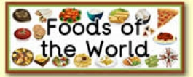

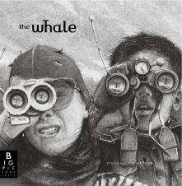
PSHE
- Recap with children what they already know about feelings and emotions. Link to year 3 teaching of grief.
- Recognise our thoughts, feelings and emotions.
- Identify differences between good and not so good feelings.
- Identify a range of strategies to help manage uncomfortable emotions. Brainstorm advice.

Understand how our emotions can affect our choices and actions.

R.E – Judaism
- To learn about “agreement”
- To explore Jewish history and learn about the covenant (agreement/promise) between God and Abraham. To identify the 10 commandments
- To evaluate how special
- Jewish relationships are with God
- To recap Jewish affirmations.
English

Writing outcomes
- Setting Narrative
- Newspaper Report

-Grammar word: Verb inflections (‘we were’ instead of ‘we was’).
-Grammar sentence: Expanded noun phrases, fronted adverbials,
-Grammar text: Nouns or pronouns to aid cohesion, paragraphs to organise ideas, using the present for of verbs.
-Grammar punctuation: Inverted commas and other punctuation to indicate direct speech, using commas after fronted adverbials.
Reading
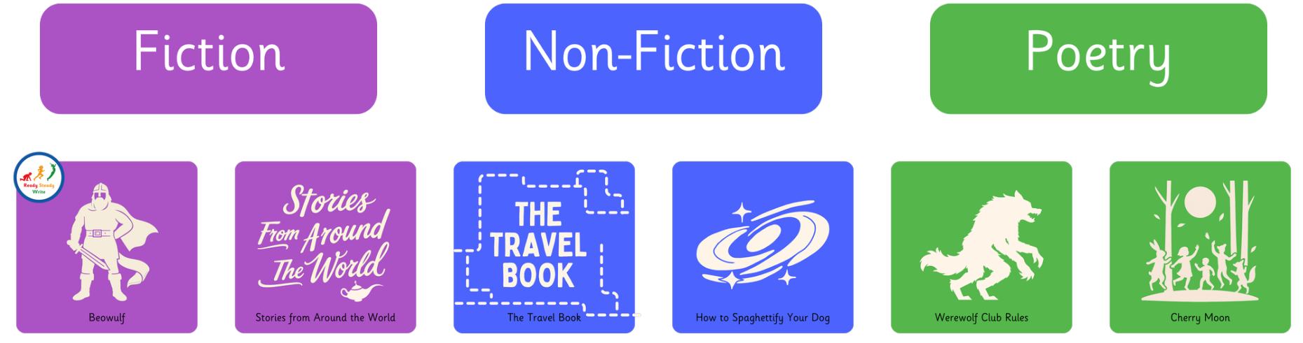

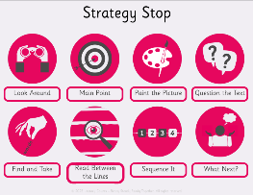
P.E
- Invasion: game sense-
passing, moving, attacking and defending with ball
- Mindfulness
Manage negative emotions, meditation, concentration, expression and emotions
Swimming
-Leytonstone leisure centre
Art- World’s Kitchen
- Focus on inspirational artist, observe artwork and discuss techniques. Explore feelings, thoughts and emotions
- Explore techniques using inspirations artwork and develop a sketch (techniques: tints, colours, textures, shades and tones)
- Critique and up level. Explore techniques using inspirations artwork and develop the sketch with the focus form of media (techniques: mixing patches, colour tone and trialling on different types of paper
- Master techniques- Creating their own version taking inspiration from the Artist.
- Evaluate techniques and compare own work with inspirational artist work.

