History/Geography: Journey through Europe

- To compare human and physical geography of a European country to the UK.
- Identify UK countries and cities on a map To use historical vocabulary to group time periods (Stone Age, Iron Age, Neolithic, Mesolithic, etc.)
- To locate the European countries on the map.
- To identify the climates of Europe
- To compare Europe to another continent in the World
Science: Animals including Humans
- To recall what a healthy and unhealthy diet is for humans with reference to nutrients our bodies needs.
- To classify different skeletal types- hydro skeleton, endoskeleton and exoskeleton
- To name the bones in a human body.
- To understand how our muscles and bones help us move.
Maths
Place Value
- Represent and partition numbers to 100 and 1000
- Find 1, 10, 100 more or less than a given number
- Count in and estimate on number lines to 1000
- Compare and order numbers 1000
- Count in 50s
Addition and subtraction
- Add and Subtract 1s, 10s, 100s
- Add and subtract two numbers without exchange
- Add and Subtract a 2-digit number from a three digit number crossing over 10 and 100.
- Estimate answers
- Use the inverse operation

Computing: Networks and Connections.

- To understand what a network is.
- To know how information moves around a network.
- To know how the internet works and how websites work.
- To explore the role of routers.
- To understand the role of packets and networks.
- Assessment for learning.
Music: Ballads

- To use musical language to describe feel of the music.
- To improve accuracy in pitch and control, singing with expression and dynamics
- To identify the patterns and repeating themes of a song.
- To sing as a part of a group in order to sing in rounds.
- To keep beat alongside a song.

Guided Reading

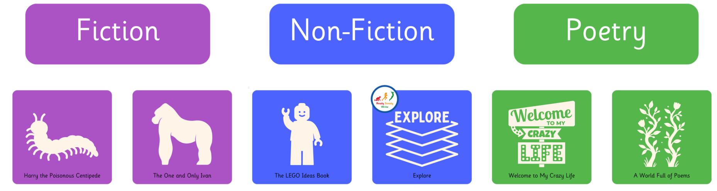

Writing

Writing outcomes

- Approaching threat narrative
- Trap explanation

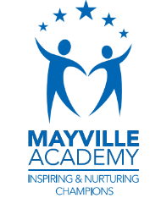
Autumn 1
This term our topic is on:
Our European Neighbours

French: Introducing Ourselves and alphabet
- To recall French greetings and feelings.
- To introduce ourselves and say how we are feeling.
- To recall the French alphabet
- To say how old we are in French.

R.E: Hinduism
Theme: Diwali
Concept: Diwali
Key Question: Would celebrating Diwali in the home and in the community bring a sense of belonging to a Hindu child?

- To explore how people feel at home and what community means to religious people.
- To recall the story of Diwali and reflect on the symbolism of the story.
- To observe how Hindus celebrate Diwali and what gods they worship during the festival.
- To recall why some families celebrate specific gods and how this can bring belonging.

PSHE: 1 Grief

Feelings and emotions: grief and sadness
- Discuss when and why people feel grief
- Identify how people show sadness and how it is different from grief.
- Describe we can cope with negative emotions

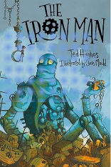

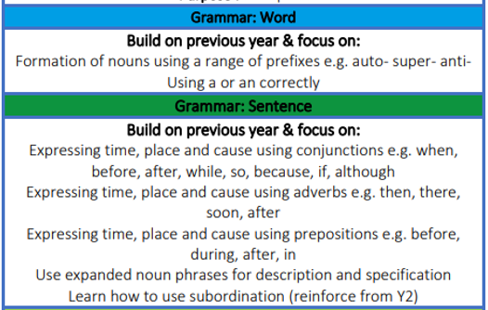

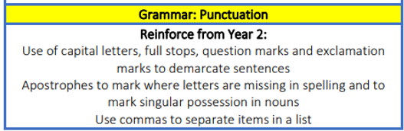
P.E

Games, Health and Wellbeing: game sense and Mindfulness
- The focus of the learning is to see how effectively pupils can apply their passing and moving skills to keep possession and to create opportunities to score points.
- The focus of the learning is to consider how we feel in our minds and in our bodies, when we experience various emotions.
Art
Skill- Painting – 3D and Sculpture
Inspirational Artist- Fernando Botero
- To take inspiration from others. Look at different paintings from artist and other 3D sketches.
- To develop shading techniques: shading light and dark tones to create dimension.
- Design a 3D sculpture.
- Practise sculpting techniques and apply to our own sculptures.
- Evaluate and analyse our work.

