Mayville Autumn 1 Learning – Seas and Coasts
Year 2
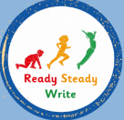  English  Writing Focus: A River – Marc Martin  Circular Narrative and Letter  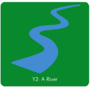  The children will explore A River and use its rich illustrations and language to develop their own ideas for writing. They will learn how to plan and write a circular narrative, developing their use of sentences, description and story structure. Children will then use their learning to write a letter, considering its purpose, organisation and the reader.  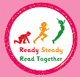  Reading Focus:  The children will read a range of fiction, non-fiction and poetry to develop their fluency, vocabulary and comprehension. They will practise retrieving information, making predictions and inferences, discussing new vocabulary and explaining their understanding using evidence from the texts. | 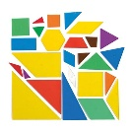  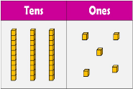  Maths  Topics: Place Value, Addition & Subtraction, Shape  The children will develop their understanding of numbers to 100 by counting, reading, writing, comparing and representing numbers in different ways. They will build confidence with addition and subtraction using practical resources, mental strategies and written methods. Children will also explore 2D and 3D shapes and describe their properties using mathematical vocabulary. | 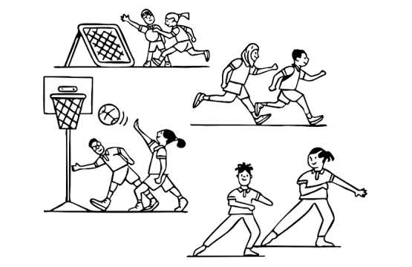  PE- Locomotion: Dodging and Creating Games  Dodging and Team Games  The children will develop their agility and learn how to dodge effectively when playing games. They will practise changing speed and direction and apply these skills in team activities. Children will also learn to cooperate with others, follow rules and respond positively to winning, losing and drawing.  Dance: Led by specialist teacher. |   PSHE  Feelings and Emotions  The children will identify and name a range of emotions and explore how feelings can affect our bodies and thoughts. They will learn that emotions can be comfortable or uncomfortable and explore strategies for managing difficult feelings. Children will also recognise that feelings can be communicated through words, facial expressions and body language. | 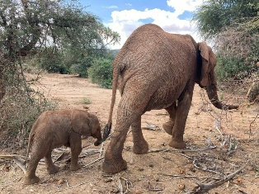  Music:  African Call and Response – Animals  The children will explore call-and-response music and learn a traditional song from Ghana. They will listen to, copy and create short rhythmic patterns using voices and instruments. Children will begin to recognise simple musical notation and explore how changing the volume can make their performances more expressive.
 | 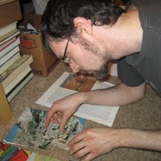  Art  Collage – Artist: Jesse Treece  The children will explore the collage work of Jesse Treece, noticing how he combines different images, colours and textures to create imaginative artwork. They will experiment with cutting, layering and arranging different papers and materials before designing and creating their own collage. Children will evaluate their work and make improvements to their final piece. | 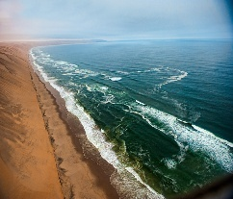  Geography  Seas and Coasts  Children will locate the seven continents and five oceans and identify the countries and seas surrounding the UK. They will explore the human and physical features of coastlines and compare British beaches with beaches in other parts of the world. Children will also use maps, compass directions and geographical vocabulary to describe locations and coastal environments. | 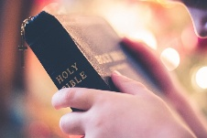  RE  Christianity – What Did Jesus Teach?  Key Question: Is it possible to be kind to everyone all of the time?  The children will explore Christian teachings about kindness through stories about Jesus. They will discuss times when being kind can be difficult and consider how our choices affect others. Children will explain why kindness is important to Christians and make connections with their own experiences. | 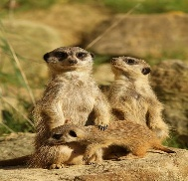  Science  Healthy Me – Animals Including Humans  The children will learn that animals, including humans, have offspring that grow into adults. They will explore the basic needs of humans and animals, including food, water and shelter. Children will learn what makes a balanced diet and identify and sort foods into different food groups.
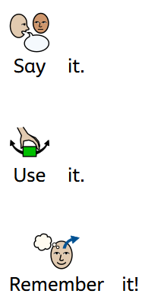  Key Vocabulary  east  west  offspring  healthy  emotion  rhythm collage  cliff  human  physical  compass  north  south  coast  ocean  sea  continent  beach |  | Value of the Term:  Kindness  Key Dates:  18th September- Jeans for Genes Day  w/c 21st September- Half Termly Trip to Leytonstone Library  22ND September- Curriculum Evening  5th October- World Teacher’s Day  w/c 12th October- National Maritime Museum Greenwich  23rd October- End of Half Term

