Mayville Autumn 1 Learning – Where Do I Live?
Year 1
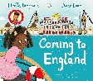  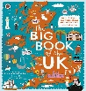  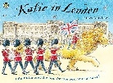  English  Focus Texts: The Big Book of the UK, Katie in London, Coming to England  The children will explore different texts linked to the UK, London, journeys, home and belonging. Through talk, role play and continuous provision, they will develop their vocabulary and orally rehearse ideas before writing. Children will learn to sequence ideas, write simple sentences and use capital letters, finger spaces and full stops, applying their phonics independently. They will create a range of purposeful writing, including information writing, a story retells, a postcard and writing about where they live and belong.  Guided Reading  The children will work in small groups each day with their teacher to develop their reading skills. They will learn how to make predictions, understand vocabulary used by an author and read fluently.  Phonics  The children will develop their phonetical knowledge and understanding in structured phonics sessions. They will strengthen their decoding, blending and fluency. | 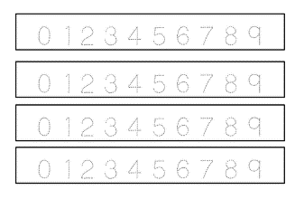  Maths  Topics: Number Formation, Place Value, Addition & Subtraction within 10  The children will develop a secure understanding of numbers to 10 by counting, reading, writing, representing, comparing and ordering numbers. They will use practical resources and number lines to explore place value. Children will also begin to understand parts and wholes, number facts and how the + and − symbols are used to represent addition and subtraction. | 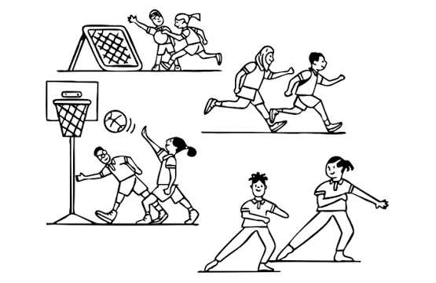  PE- Locomotion: Dodging and Creating Games  Dodging and Team Games  The children will develop their agility and learn how to dodge effectively when playing games. They will practise changing speed and direction and apply these skills in team activities. Children will also learn to cooperate with others, follow rules and respond positively to winning, losing and drawing.  Dance: Led by specialist teacher. |   PSHE  Feelings and Emotions  The children will recognise and name a range of emotions and explore how feelings can affect their minds and bodies. They will explore feelings such as jealousy and learn strategies for managing uncomfortable emotions. Children will also develop their understanding of classroom expectations and the Golden Rules that help everyone feel safe and respected. | 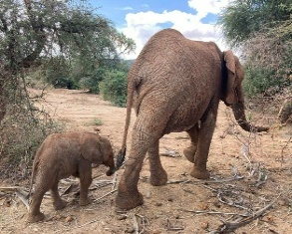  Music:  African Call and Response – Animals  The children will explore call-and-response music and learn a traditional song from Ghana. They will listen to, copy and create short rhythmic patterns using voices and instruments. Children will begin to recognise simple musical notation and explore how changing the volume can make their performances more expressive.
 | 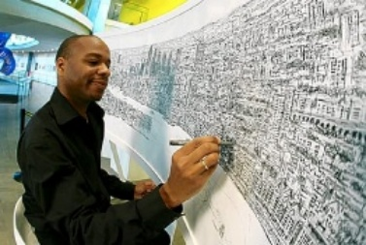  Art  Drawing- Stephen Wiltshire  The children will explore the detailed drawings of Stephen Wiltshire and develop their own drawing skills. They will experiment with different lines, shapes, marks and textures, learning to look carefully and draw from observation. Children will apply these skills to create a detailed drawing inspired by buildings and places in their local area. | 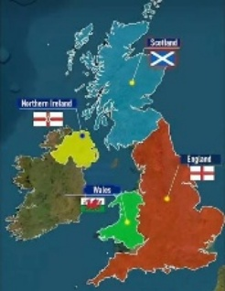  Geography  Where Do I Live?  The children will explore where they live, beginning with the wider world and gradually focusing on their local area. They will name the seven continents, locate the UK on a world map and identify the four countries and capital cities of the UK. Children will explore London and Leytonstone, identify local features and begin to describe where they live using geographical vocabulary. | 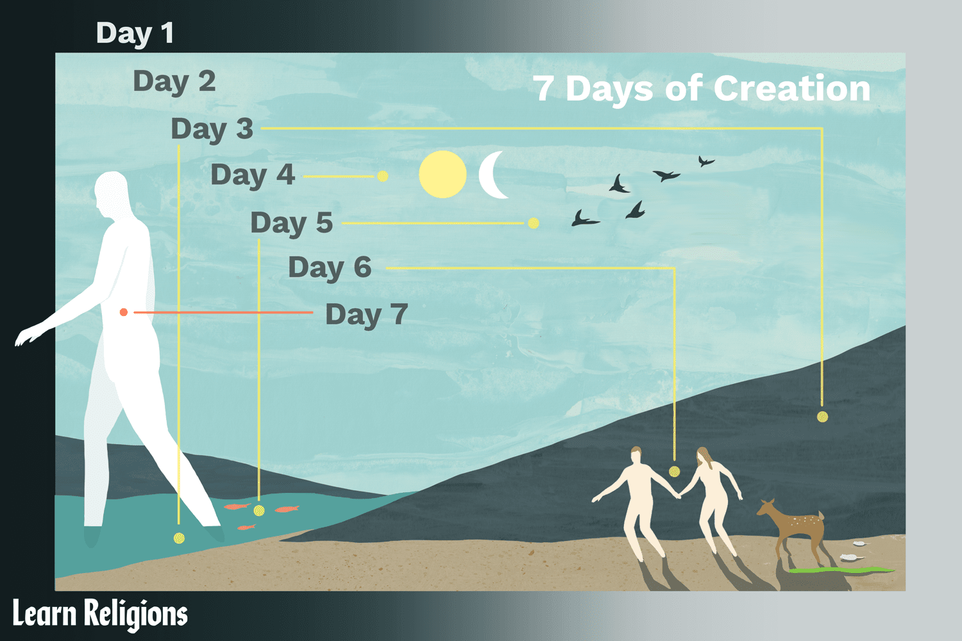  RE  Christianity – The Creation Story  Key Question: Does God want Christians to look after the world?  Children will learn about the Christian Creation Story and explore Christian beliefs about God as the creator of the world. They will discuss why Christians believe the world should be cared for and consider practical ways that people can look after the environment. | 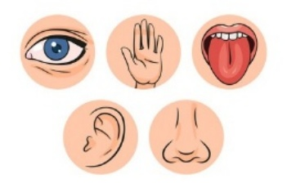  Science  The Human Body  The children will identify, name and label the main parts of the human body. They will investigate the five senses – sight, hearing, taste, touch and smell – and identify which parts of our bodies help us to use each sense. Children will carry out simple observations and investigations to explore how their senses help them understand the world.
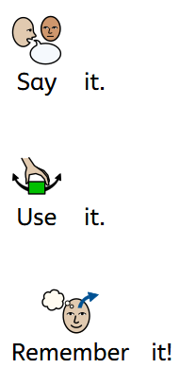  Key Vocabulary  continent  country  United Kingdom England  London  senses  creation  emotion  pulse rhythm  addition subtraction  capital city  local  map landmark  body |  | Value of the Term:  Kindness  Key Dates:  w/c 21st September- Local Area Walk- Observations  18th September- Jeans for Genes Day  w/c 28th September- Half Termly Trip to Leytonstone Library  22ND September- Curriculum Evening  5th October- World Teacher’s Day  w/c 19th October- London Museum Docklands  23rd October- End of Half Term

