Mayville Autumn 1 Learning – My Identify
Reception
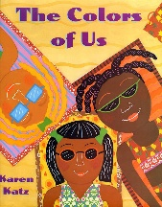  Literacy  Focus Texts:  The Colour of Us  All Are Welcome  Owl Babies  The children will enjoy stories about families, friendships, feelings and belonging. They will learn new vocabulary, retell stories and begin writing labels, captions and simple sentences. Through daily phonics sessions, children will learn new sounds and practise forming letters correctly. | 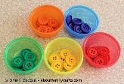  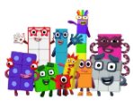  Maths  Topics: Matching, Sorting and Comparing,  Measures and Patterns  It's Me! 1, 2, 3  The children will develop their mathematical understanding through matching, sorting and comparing objects. They will explore size, weight, capacity and simple repeating patterns. The children will also learn to recognise, count and represent the numbers 1, 2 and 3 through practical play, hands-on activities and Maths through stories. |  | Physical Development  Fine Motor  The children will develop their fine motor skills through threading, cutting, playdough, painting and mark-making. They will also practise forming letters correctly and develop independence when managing their personal belongings, including putting on coats and fastening zips.  Gross Motor  The children will develop their balance, coordination and core strength. They will explore different ways of moving, travelling and using equipment safely while building confidence in their physical abilities. |   Personal, Social and Emotional Development  Children will learn how t access the Snack trolley which promotes independence, choice and physical development. The children will develop positive relationships with adults and their peers as they settle into Reception. They will learn classroom routines, explore their feelings. The children will develop confidence, independence and an understanding of how to be kind, respectful and inclusive members of our Mayville community. | Key Vocabualary:  To develop your child’s vocabulary, discuss the following words:  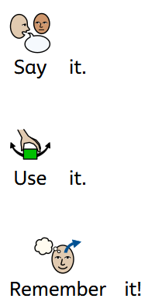  identity  family  belong  community  tradition  autumn  different  same  feelings  respect
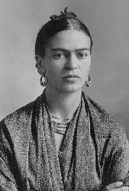    Expressive Arts and Design  Focus Artist and Musician: Frido Kahola and Stevie Wonder  The children will develop their artistic skills through the exploration of spring colours, painting, collages and printing. They will take inspiration from the natural world around us and create Spring-themed pieces. In Music, the children will explore different forms of transport.  Nursery rhymes |  |   Understanding the World  The children will explore: My Identity  - What makes me special?  - Who is in my family?  - What makes us the same and different?  Seasonal Changes  - changing leaves  - weather changes  - signs of Autumn in our local area  Local Community  The children will learn about their school, local area and community. |  |   Communication and Language  The children will develop their speaking and listening skills through:  - story times  - role play  - partner talk  - circle time  They will learn to speak in full sentences and use new vocabulary to talk about themselves, their families and their experiences. | Value of the Term:  Kindness  Key Dates:  7th September – 14th September: Transition Week-  15th September- First Full Day  28th September- Local Area Walk  5th October- Library visit  13th October - Museum of the Home-  22nd October- Identify Celebration Gallery

