Mayville Autumn 1 Learning – My Identify
Nursery
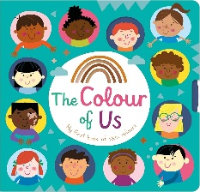  Literacy  Focus Texts:  Lulu’s First Day, The Colour Monster, So Much!  The children will explore stories about starting Nursery, feelings, family and belonging. They will learn new vocabulary, join in with repeated phrases and begin to retell familiar parts of stories. Through drawing and mark-making, children will give meaning to their marks, recognise their name and begin to make marks and letter shapes from their name. | 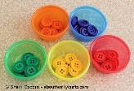  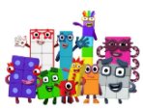  Maths  Topics: More, less and fewer than, shapes, space, measure and counting.  The children will develop early number skills through practical play, stories and songs. They will practise matching and sorting objects, comparing size and amounts and noticing simple patterns. Children will develop their understanding of numbers through counting, recognising small quantities and using number language during everyday play. |  | Physical Development  Fine Motor  The children will develop their fine motor skills through threading, cutting, playdough, painting and mark-making. They will also practise forming letters correctly and develop independence when managing their personal belongings, including putting on coats and fastening zips.  Gross Motor  The children will develop their balance, coordination and core strength. They will explore different ways of moving, travelling and using equipment safely while building confidence in their physical abilities. |   Personal, Social and Emotional Development  The children will develop confidence and a sense of belonging as they settle into Nursery. Through 1decision, they will explore separating from important adults, recognising and communicating feelings, sharing and joining others in play. Children will begin to build friendships, follow Nursery routines and develop independence in managing their own needs. | Key Vocabualary:  To develop your child’s vocabulary, discuss the following words:  identity  family  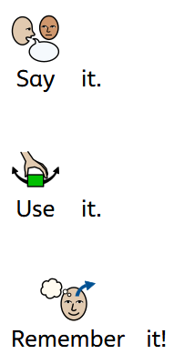  home  belong  Nursery  Feelings  Same  Different  Friend  Community  Autumn  Changes  Pattern  Rhythm
  Expressive Arts and Design  Focus Artist: Alma Woodsey Thomas  The children will explore colour, pattern and movement through art.    Focus Musician: Nusrat Fateh Ali Khan  In music, they will develop their listening skills, explore rhythm and use their voices, bodies and instruments to make music. |  |   Understanding the World  The children will explore who they are and where they belong, talking about themselves, their families, homes and important people. They will explore similarities and differences between themselves and others and become familiar with their Nursery and local community. Children will also observe seasonal changes and investigate signs of Autumn in their environment. |  |   Communication and Language  The children will develop their speaking and listening skills through:  - story times  - role play  - partner talk  - circle time  They will learn to speak in full sentences and use new vocabulary to talk about themselves, their families and their experiences. | Value of the Term:  Kindness  Key Dates:  3rd- First Day Back  28th September- Local Area Walk  8th October- Library visit  22nd October- Identify Celebration Gallery

