Friday 15th May 2026
Head Teacher Message
Dear Parents and Carers,
Our Year 6 pupils have shown tremendous determination and maturity throughout their SATS assessments this week. We are incredibly proud of the calm, focused and resilient way they approached each paper. Their teachers have worked tirelessly to prepare them, and the children have truly risen to the challenge. Whatever the outcomes, they have demonstrated the qualities that matter most: effort, perseverance and pride in their learning.
Football Friendly Matches
Last week also brought great excitement on the sports field as we hosted a series of friendly football matches with our neighbours at George Tomlinson. The games were full of energy, teamwork and brilliant sportsmanship from both schools. It was wonderful to see so many pupils representing Mayville with confidence and enthusiasm, and we look forward to more opportunities to strengthen this partnership.
Year group newsletter contributions
You will notice a new feature in our newsletter this term: class contributions. Each week, a different class will share a snapshot of their learning, creativity or achievements. This is a fantastic way to celebrate the rich experiences happening across the school and to give families a closer look at the exciting work taking place in classrooms every day. We hope you enjoy hearing directly from the children.
Walk to school week 
Finally, we are preparing for Walk to School Week, which begins next week. This is a great opportunity to promote healthy habits, reduce traffic around the school and encourage children to start the day feeling energised. We hope many of you will join us in supporting this initiative and making it a positive, community‑wide effort. Thank you, as always, for your continued support and partnership

Sharon Parson (Head teacher)
Year 1 News update
We are now well into Summer Term 1 and Year 1 have had a fantastic start to the term. The children have settled brilliantly and have already enjoyed a busy and successful few weeks, showing enthusiasm, confidence and creativity across all areas of learning. Thank you for your continued support at home.

Literacy
This term in Literacy, the children have had lots of fun developing their reading, writing, and storytelling skills. They enjoyed sharing stories together, using their imagination, and becoming more confident writers and readers every day. It has been wonderful to see their enthusiasm and creativity shine through in all of their work.
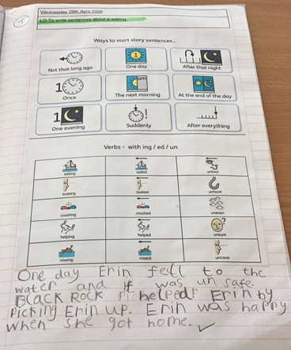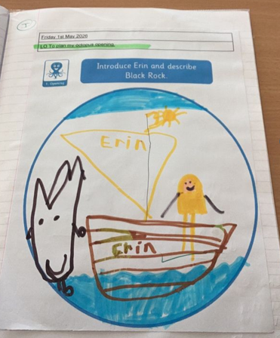

Maths
In Maths, the children have been excitedly practising counting in 2s, 5s, and 10s through games, songs, and practical activities. They also explored sharing and making equal groups, helping them build a strong understanding of early multiplication concepts in a fun and engaging way.
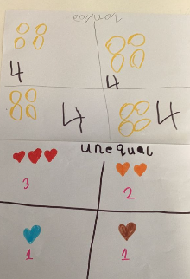

Science
In Science, we had a fantastic time learning about the different parts of trees and plants. The children enjoyed exploring nature, identifying plant parts, and discovering what plants need to grow healthy and strong. Their curiosity and excitement during investigations made learning especially enjoyable.
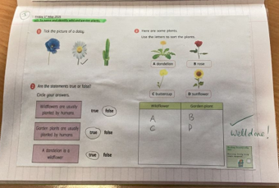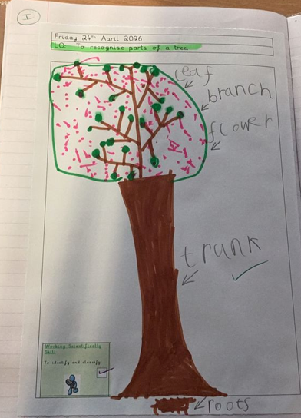

Geography
In Geography, we had an exciting journey learning about animals around the world and the habitats they live in. The children loved finding out interesting facts about animals from different countries and comparing environments across the globe. It has been a fun and engaging topic that sparked lots of curiosity and discussion
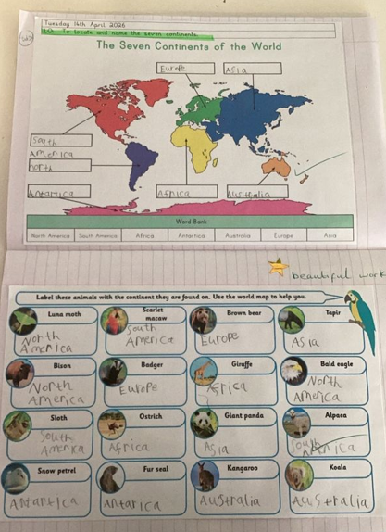

Mayville Sports league news
Competition, confidence and school spirit continue to grow across Mayville as the Sports League heads towards an exciting finale.




By Coach Charles

The four teams of the Mayville Sports League: Blue Sharks, Red Dragons, Green Eagles and Yellow Lions.
The atmosphere around the Mayville Sports League has continued to grow throughout the year, with pupils proudly representing their teams, regularly checking standings and competing with determination each week.
Across football, handball, capture the flag and basketball, pupils from all year groups have shown incredible enthusiasm, resilience and teamwork while representing the Blue Sharks, Red Dragons, Green Eagles and Yellow Lions.
🏆 Champions So Far
Football Champions: Blue Sharks Handball Champions: Red Dragons
Capture the Flag Champions: Green Eagles Basketball Champions: Blue Sharks
Sports Roulette: Yellow Lions
Every competition has brought memorable matches, healthy rivalries and moments of teamwork that have made the league exciting from start to finish.
⭐ FEATURE QUOTE
“The biggest success of the league has not just been the results, but the confidence children have gained through sport.”

🏅 Player of the Term Winners
Blue Sharks: Vlad (Yr 5), Piskerly (Yr 5) x2, Mishal (Yr 4), Vlad (Yr 6)
Red Dragons: Kaileb (Yr 4) x2, Mikey (Yr 6), Hassan (Yr 5)
Green Eagles: Aiden (Yr 5) x2, Taiyan (Yr 6), Tudor (Yr 3)
Yellow Lions: Yahya M (Yr 4), Ella (Yr 6)x2, Ismael (Yr 5)
Pupils competing with determination and pride during Mayville Sports League fixtures.
Beyond the medals and awards, one of the greatest successes of the league has been the growth shown by so many pupils throughout the year. Children who were once hesitant to participate are now stepping forward confidently, leading teammates, volunteering in matches and embracing competition with enthusiasm.
With Sports Week and Sports Day fast approaching, the Mayville sporting calendar is building towards an exciting finale. Pupils across the school are looking forward to one final opportunity to represent their teams, compete with pride and celebrate everything achieved throughout the year.

Important Dates for the diary
(Summer Term)
Event | Date | Time
‘Walk to school week’   | 18th May-22nd May | All day
Year 2 Buddhism Assembly | Tuesday 19th May | 9.15am-10.00am
Year 1 Phonic screening meeting-Ms Brown | Wednesday 20th May | 9.00am  or  3.15pm
Football friendly Match  George Tom Vs Mayville | Thursday 21st May | 1.30pm-2.30pm
Half Term
25th May -29th May
Children Return | Monday 1st June | -
Year 3-Sun Safety workshop  Year 6-Transition to Secondary school | Tuesday 2nd June | 9.30am-11.00am
Year 4 Trip-Soanes Centre (Mile End) | Thursday 11th June | 9.00am-3.00pm
Reception Open Morning | Thursday 11th June | 9.15am-10.45am

Mayville Virtues
Autumn  Kindness | Spring  Respect | Summer  Determination

Language of the Month
Albanian
Word of the Month
Përshëndetje (Hello) Faleminderit (Thank you),

Rights Respecting
Article 24
‘Every child has the right to the best possible health’

