History: Crime and Punishment

- Talk about and compare the punishments that were used during the Roman, Anglo Saxon, Tudor and Victorian times and give some reasons for them.
- Explain some key terms in the history of crime and punishment in Britain, such as wergild, trial by ordeal, tithings, hue and cry, treason, transportation and hard labour.
- Use primary sources to decide what are facts, what opinions can be formed from the evidence, and identify the questions they have about the life of the highway man Dick Turpin.
- Compare modern day crime and punishment with those from the past, and talk about the legacy of past methods of crime prevention and detection with those of the present day.
- Imagine and write about the experiences of people living during the historical periods studied based on factual evidence.
Science: Circulatory System
- Recognise the function of the circulatory system.
- Identify the three main parts of the circulatory system.
- •Understand the function of the heart.
- •Understand the function of the blood vessels.
- •Know what blood is and its role in the body.
- •Identify the three main types of blood vessels.
- •Understand the function of arteries, veins, and capillaries.

Maths

Revision and preparation leading upto SATs:
Place Value: Roman numerals, negative numbers, rounding estimation and money
Number properties: factors, multiples, roots, powers and prime numbers
4 operations: addition, subtraction, multiplication, division, doubling and halving, inverse, order of operations and brackets.
Statistics: pie charts, table, bar charts, pictograms, line graphs, scatter graphs and tall charts
Fractions, decimals and ratios: fractions, decimals, percentages, equivalence and ratio
Time: 12 hour, 24 hour, calendar, timetable, converting between times

Computing: Introduction to Python
-Identify key similarities and differences between block-based code and text-based Python. Predict what a Python program will do before it is run.
-Explain how Python instructions work and why correct syntax and indentation matter. Spot and fix simple syntax errors, including typing and spacing mistakes.
-Identify and explain the role of the outer and inner loops in a nested loop program. Change loop values and describe how this affects patterns or movement.
- Modify existing Python code to create a new, intended outcome.

French: Planning a French Holiday
-Remember the countries in the world in French.
-Use a writing model to create a complex sentence.
-Begin to understand the present and future tense of ‘aller’ in French.
-Identify the present and future tenses in reading and listening.
-Label images of clothing correctly.
-Speak in sentences and write a paragraph.
-Recognise familiar words and cognates.

Year 6
Spring 2
This term our topic is on:
Crime and Punishment
Music: Themes and variations (Theme: Pop Art)
- To explore the musical concept of theme and variations
- To compare and contrast different variations in the piece ‘The Young Person’s Guide to the Orchestra’
- To use complex rhythms to be able to perform a theme
- To play TIKI-TIKI, TI-TIKI and TIKI-TI rhythms in 3/4 time
- To use music notation to create visual representations of TIKI-TIKI, TI-TIKI and TIKI-TI rhythms.

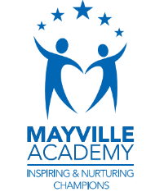

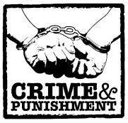
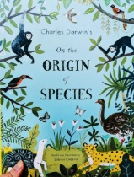
PSHE: 1 Decision
Our World: In app purchases
British Value: Democracy Respecting Opinions
- Know and understand various money-related terms
- Recognise some of the ways in which we can spend money via technology
- Describe the potential impact of spending money without permission identify strategies to save money

English
Writing outcomes
- Discover narrative (purpose- to narrate)
- Explanation text (purpose- to explain)
-Grammar word: The difference between vocabulary of informal speech and vocabulary appropriate to formal speech and writing Develop understanding of how words are related by meaning as synonyms and antonyms
-Grammar sentence: Using expanded noun phrases to convey complicated information concisely
-Grammar text: Linking ideas within and across paragraphs using a wider range of cohesive devices – adverbials
-Grammar punctuation: Use semi-colons to mark the boundary between independent clauses Use colons to mark the boundary between independent clauses. Use dashes to mark the boundary between independent clauses Use colons to introduce a list. Use brackets to indicate parenthesis.
Reading

R.E: Christianity
Theme: Easter
Concept: Gospel
Key Question: Is Christianity still a strong religion 2000 years after Jesus was on Earth?
Religion: Christianity
- Explain how the influence people have had on me has affected what I see as important.
- Explain how one of the reasons people use to suggest that Christianity is a strong religion today can be counteracted.
- Share opinions as to whether Christianity is a strong religion now and say why I think this.

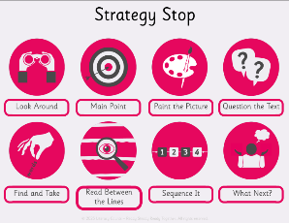
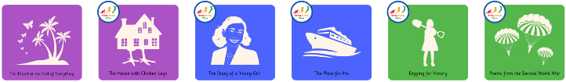
P.E
Invasion: Hockey
- Consolidate pupils ability to use passing, dribbling and moving skills to keep possession and score
- Learning of passing, dribbling and moving, to keep possession and create an attack that results in a successful shot
- Refine their knowledge and understanding of defending (marking, tackling and blocking) and how this is applied during a game to prevent attacking opportunities.
- Learning of passing, dribbling and moving, to create effective attacking tactics that results in a successful shot.
DT Digital World: Navigating the World
Children program a navigation tool to produce a multifunctional device for trekkers. They combine 3D objects to form a complete product in CAD 3D modelling software.

- To write a design brief and criteria based on a client request
- To write a program to include multiple functions as part of a navigation device
- To develop a sustainable product concept
- To develop 3D CAD skills to produce a virtual model
- To present a pitch to ‘sell’ the product to a specified client

