Maths
Fractions
- Multiply unit, non-unit fractions and mixed numbers by an integer
- Calculate fractions of a quantity, find fractions of an amount and find whole
- Use fractions as operators
Decimals and percentages
- Decimals up to 2 decimal places
- Equivalent fractions and decimals (tenths and hundredths)
- Thousandths as fractions and decimals
- Order and compare decimals
- Round to the nearest whole number and 1 decimals place
- Understand percentages, percentages as fractions and percentages as decimals
- Equivalent fractions, decimals and percentages
Perimeter and area
- Perimeter of rectangles, rectilinear shapes and polygons
- Area of rectangles and compound shapes
- Estimate area

Science: Animals including Humans
- Explore the human life cycle
- Explore key milestones for babies and children
- Explore key changes that happen to humans in adulthood
- Understand how gestation takes place in animals and humans
- Explore key features of the life cycle of mammals and amphibians
- Explore key features of the life cycle of insects and birds
- Use relevant scientific language and illustrations to discuss, communicate and justify scientific ideas
- Record data using scientific diagrams

History: China and Shang Dynasty
- To find out about the Shang Dynasty of China and explore how we know about it.
- To explore the evidence surrounding the Shang kings.
- To find out about the Shang royal burials.
- To find out what ordinary life was like for people during the Shang Dynasty.
- To find out about the writing and calendar created during the Shang Dynasty.
- To find out why the Shang Dynasty ended.
- To know that some historical sources are written thousands of years after the event and are thus unreliable.
- To know that archaeologists use evidence from the oracle bones to learn about the Shang Dynasty.
- To compare evidence about the Shang Dynasty from traditional history books and archaeologists and state which is more reliable
- To know that some histor8ical sources are written thousands of years after the event and thus unreliable.

Computing: Programming Microbit
- Clip blocks together and predict what will happen
- Make connections with previous programming interfaces e.g. Scratch
- Create images to make animations
- Recognise the difference between ‘on start’ and ‘forever’
- Recognise blocks used previously, identifying inputs and outputs used
- Make predictions about how variables work
- Choose appropriate blocks to complete the program


Music: Composition (Hinduism- Holi theme)
- Suggest a colour to match a piece of music
- Create a graphic score and describe how this matches the general structure of a piece of music
- Create a vocal composition in response to a picture and justify choices using musical terms
- Create a vocal composition in response to colour

Spring 2
This term our topic is on:
China and Shang Dynasty

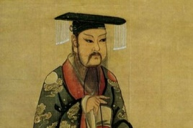
PSHE: 1 Decision
Our World – Enterprise
- Understand and explain why people might want to save money
- Identify ways in which you can help out at home
- Budget for items you would like to buy
- Recognise ways to make money and the early stages of enterprise

English
• Vehicle Text: The Promise
•
Writing Outcome & Writing Purpose
- Narrative: Character Narrative
  - Purpose: To narrate
- Non-Narrative: Bargain Letter
  - Purpose: To persuade
• Grammar: Word
- Build on previous units & focus on:
  - Develop understanding and use of verb prefixes
• Grammar: Sentence
- Build on previous units & focus on:
  - Indicate degrees of possibility using adverbs
  - Indicate degrees of possibility using modal verbs
• Grammar: Text
- Develop understanding in using devices to build cohesion within a paragraph
• Grammar: Punctuation
- Build on previous units & focus on:
  - Commas to indicate parenthesis

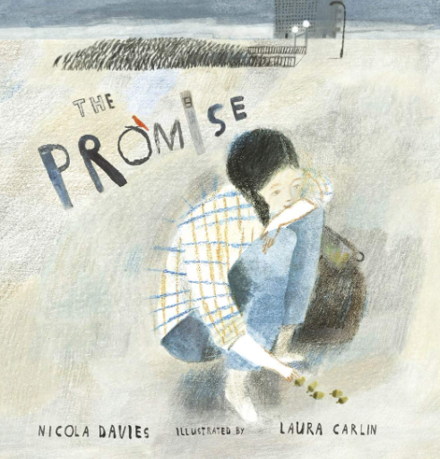

R.E: Christianity
Theme: Easter
Concept: Salvation
Key Question: How significant is it for Christians to believe God intended Jesus to die?
- To explore what destiny means
- To explore God’s plan for Jesus
- To explore the main events of Holy Week
- To analyse Biblical texts regarding Jesus’ crucifixion
- To evaluate the evidence regarding Jesus’ crucifixion
- To research on people who have had a strong purpose or sense of destiny
- To reflect on our own dream/ambition/purpose

PE- Dodgeball
- Block a ball thrown during a game
- Recognise and catch a ball during a game
- Throw with accuracy and power
- Apply basic attacking techniques in a game
- Apply basic defensive techniques in a game
- Level 1 tournament

D.T: Bridges

- Arch and beam bridges
- Spaghetti truss bridges
- Building bridges
- Finalising Bridges and Evaluation

