Decimals
-Tenths as fractions
-Tenths as decimals
-Tenths on a place value chart
-Tenths on a number line
-Divide a 1 or 2 digit number by 10
-Hundredths as a fraction
-hundredths as a decimals
-Hundredths on a place value chart
Divide 1 or 2 digit number by 100

History- Maya Civilisation
- To explore where and when the remains of the Mayan civilisation were discovered.
- To find out about how the Mayans civilisation developed over time
- To find out about the city states of the Maya and how society was organised.
- To find out about Mayan religion and beliefs.
- To find out about everyday life for the Mayan people
- To explore Mayan writing and calendars.
- To find out about the decline of the Mayan civilisation.
Science: Seasonal data, electricity, sustainability- energy
- Collect data to analyse how seasons influence animal and plant life
- Recognise common appliances that use electricity
- Build and draw series circuits
- Recognise conductors and insulators
- Investigate conductivity within a circuit
- Recognise what energy is and how we can reduce our energy usage
Maths

Length and Perimeter
- Measure in km and m
- Equivalent lengths (km and m)
- Perimeter on a grid
- Perimeter of rectangle
- Perimeter of rectilinear shapes
- Finding missing lengths
- Calculate perimeter
- Perimeter of a regular polygon
- Perimeter of polygons
Fractions
- Understand the whole
- Count beyond 1
- Partition a mixed number
- Number lines with mixed numbers
- Compare and order mixed numbers
- Understand improper fractions
- Convert mixed numbers to improper fractions
- Convert improper fractions to mixed numbers
- Equivalent fractions
- Add two or more fractions
- Add fractions and mixed numbers
- Subtract two fractions
- Subtract from whole amounts
- Subtract from mixed numbers.


Computing: HTML

- To understand and identify examples of HTML tags
- To change HTML code for a specific purpose
- To change the HT<ML and CSS to alter the appearance of an object on the web
- To understand and explore more complex components of a web page
- To alter key elements on a webpage including text and images.
Spring 2
This term our topic is on:
Shang Dynasty



French: Weather
- Describe the weather in French speaking countries
- Notice that definite / indefinite article changes to gender of noun
- Write a few simple sentences from memory
- Complete a paragraph on a French speaking country with the relevant information
- Communicate by presenting short pieces of information
- Use the set travel sentences to describe how to travel to another (French speaking) country

Music: Romans
- To identify the structure and texture of music
- To use body percussion
- To use a tuned percussion to play a chord progression
- To create simple tunes
- To build and improve a composition

R.E: Christianity
Theme: Easter-
Concept: Salvation
Key Question: Is forgiveness always possible for Christians?
- To explore what it means to forgive and be forgiven
- To analyse biblical texts on forgiveness
- To explain how Jesus demonstrated forgiveness
- To understand Christian beliefs on forgiveness
- To evaluate the possibility of always being able to forgive
- To reflect on our own behaviour
English
Writing outcomes
- Twisted narrative (purpose- to narrate)
- Letter (purpose- to persuade)
-Grammar word: Grammatical differences between plural and possessive – s
Indicating possession by busing the possessive apostrophe with plural nouns
Develop understanding of standard English form for verb inflections instead of local spoken forms
-Grammar sentence: Noun phrases expanded by the addition of modifying adjectives, nouns and prepositions
-Grammar text: Paragraphs to organise ideas around a theme
-Grammar punctuation: Use comma after fronted adverbials, use commas after the reporting clause and use of end punctuation within inverted commas.
Reading

PSHE: The working World

- Identify ways in which we can help those who look after us.
- Explain the positive impact of our actions
- Describe the ways in which we can contribute to our home, school, and community.
- Identify the skills we may need in our future job roles

P.E
Invasion: Hockey Dance: Cats
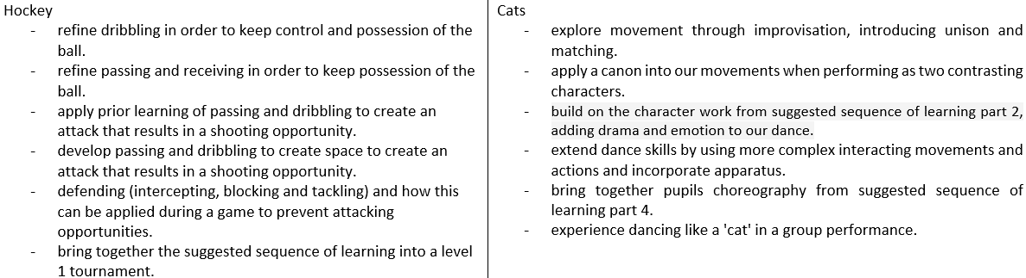
Design and Technology
Textiles – Fastening

- To identify and evaluate different types of fastenings
- To design a product to meet design criteria
- To make and test a paper template
- To assemble a book jacket
- To evaluate and assess design skills

