History
- To understand the terms ‘invade’ and ‘settle’ and to place the Romans on a timeline.
- To find out why and how the Romans successfully invaded Britain
- To find out who was in Britain when the Romans invaded and learn about their way of life
- To explore who Boudica was from different points of view
- To find out about the results of Boudica’s revolt
- To find out about life in Roman Britain
Science: Light
- To recognise sources of light and what only reflects light.
- To classify objects into translucent, transparent and opaque objects.
- To explain how shadows are made and why they change shape or size.
- To understand the dangers associated with the sun and how to protect our eyes from the sun.

Maths

Length and Perimeter
-Comparing , adding and subtracting lengths.
-Measure and calculate perimeter.
-Measure in cm, mm and m.
-Learn about equivalent lengths.
Fractions
-Understand denominators of unit fractions.
-Understand the numerator of the non-unit fraction.
-Compare and order unit fractions.
-Learn about fractions and scales.
-Learn about equivalent fractions on a bar model and a number line.

Fractions
To understand the denominators of unit fractions.
To compare and order unit fractions.
To understand the numerators of non-unit fractions.
To understand the whole.
To use equivalent fractions on a number line.
To use equivalent fractions as bar models.

Spring 2
This term our topic is on:
Roman rule

Computing: Computer components.

- To recognise basic inputs and outputs of a computer. .
- To decompose a laptop
- To understand purpose of computer parts.
- To decompose a table computer.


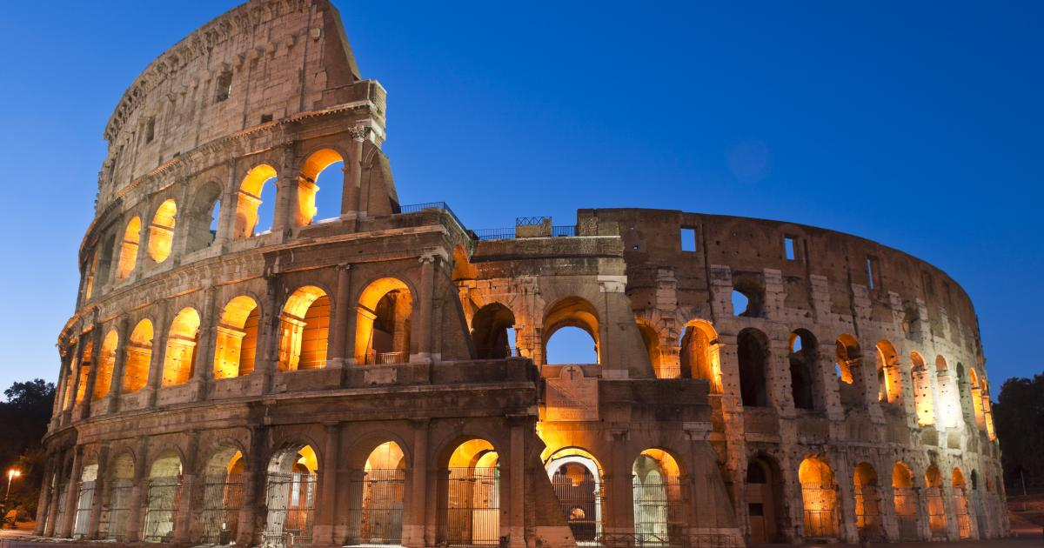

French: Travel to a French speaking country
Understand where French is spoken in the world
Review the concept of francophonie
Revisit the weather sentences previously learnt
Present the typical weather in these countries
Notice that definite / indefinite article changes to gender of noun
Practise the words for modes of transport

Say a few simple sentences expressing ways to travel

Associate the mode of transport to a country we want to travel to

Music: Composition and scales
- To use musical language to describe feel of the music.
- To learn about the music of the world.
- To play a pentatonic melody.
- To write and perform a pentatonic melody.
- To perform a group composition. .

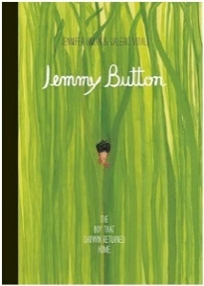
R.E: Christianity
Theme: Easter-Forgiveness
Concept: Salvation/Gospel
Key Question: What is good about Good Friday?
- Discus and understand the story of Easter Sunday and the Last Supper and its significance.
- Understand the events of Good Friday and what a crucifix is.
- Explore why people call it Good Friday.
- To demonstrate love and gratitude to people who are special to them.
Reading

Writing
Outcome and Purpose
Narrative: Return Narrative
Purpose: To narrate
Information: Letters
Purpose: To recount
- Build on previous units & focus on: Use of the forms a or an when next word starts with a consonant or a vowel Word families based on common words showing how words are related in form and meaning
- Build on previous units & focus on: Expressing time, place and cause using prepositions e.g. before, after, during, in, because, of Expressing time, place and cause using adverbs e.g. then, next, soon, therefore Use a wider range of conjunctions, e.g. when, if, because, although
- Build on previous units & focus on: Present perfect form of verbs in contrast to the simple past
- Build on previous units & focus on: Inverted commas to punctuate direct speech
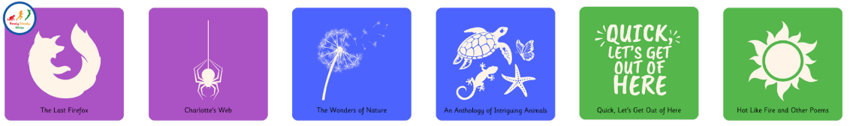
PSHE: Our World.
Looking after our world

- Discuss what responsibilities we have living in the world.
- Understand what is meant by reduce, reuse, recycle
- Discuss the dangers our world faces.

P.E
Tag Rugby
The focus of the learning is to introduce moving with the ball, passing and receiving in order to keep possession of the ball.
How can we win a game of tag rugby?

Design and Technology
Skill- Food and Preparation

- To know how climate affects food growth.
- To understand how important affects the environment.
- Understand what seasonal vegetables are in Britain.
- Preparing vegetables and fruit to make fruit skewers.
- Design a recipe using seasonal vegetables.
- Construct a vegetable tart and rhubarb crumble.

