Science: Living and their habitats
- Investigate habitats in our local area
- Recognise what plants and animals live in polar and desert habitats
- Recognise what plants and animals live in ocean and woodland habitats
Recognise what microhabitats are and what animals live there
- Explore how habitats affect the diet of animal
- Understand how energy is passed on in food

History: London’s Burning

- This term we will be exploring The Great Fire of London.
- Children will gain historical knowledge of this significant event in history and be able to use information to describe the differences between then and now.
- The children will also be gathering information from sources, for example books and pictures to aid their interpretation of history.
- The children will become historians to discover when and how The Great Fire of London began, where it took place and the impact of the fire on life today.

Maths

Fractions
Recognise, find, name and write fractions 1/3, 1/4, 2/4 and 3/4 of a length, shape, set of objects or quantity and demonstrate an understanding that all parts must be equal parts of the whole.

Statistics
Collecting data and analysing data. Understanding the use of various graphs such as pictograms, tally charts and block graphs and learning how to read and interpret data.

Geometry: Properties of Shapes
Compare and sort common 2D and 3D shapes and everyday objects describing similarities and differences.

Computing: Stop Motion
- Exploring the words animation and creating a flip book
- Creating a space themed stop motion animation
- Planning a space themed stop motion animation
- Evaluating their animations


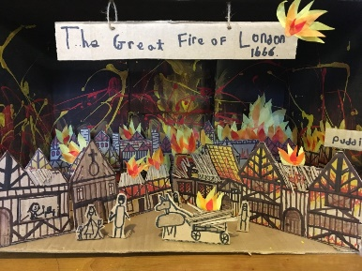
Year 2
Spring 2
This term our topic is on:
London’s Burning

PSHE: 1 Decision
Living in Our World – Working in Our World
British Value –Good and Bad choices
Exploring what is needed for a healthy family life, understanding that it is important to care for, protect, and spend time with each other
Exploring people in the community and their different roles and responsibilities.
Exploring money and understanding that it comes in different forms and from different sources

Music: Theme : Space

We will be using the space theme to explore dynamics, timbre, tempo and motifs.
Children will by the end of term create short sequences of sound and perform with accuracy

R.E: Christianity
Theme – Easter – Resurrection

Concept – Salvation

Key Question:
How important is it to Christians that Jesus came back to life after His crucifixion?
We are learning to re- tell the Easter story and understand what Jesus’ resurrection means for Christians.

English
Writing outcomes
Finding Narrative – Purpose to narrate
Grammer word – using suffix -ly
Grammer sentence – expanded noun phrase, questions and exclamation
Grammer text – past and present tense
Grammer Punctuation – capital letter, full stop, question mark, commas and apostrophes
Reading
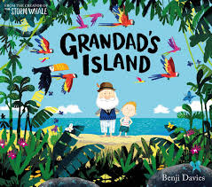

P.E
- The focus of the learning is to respond to the stimulus using a range of different, controlled movements.
- At the end of the term, Pupils will bring together their sequences exploring the relationship between the explorer and wild animal.
- Additionally, children are focusing on the balls skills with their hands
- The focus of the learning is to develop pupils' execution of an underarm throw and to extend their understanding of why we need to be accurate when we throw.
DT Digital World: Making a pouch (sewing)

This term Year 2 will be learning about the skills used to join fabrics together. They will be exploring products that are sewn together and identifying the different methods used to join fabrics together.

Children will have the opportunity to sew different materials together using a running stitch.

The children will be designing and producing a pouch using the skills learnt.




