History
- To be able to describe the characteristics of toys.
- To find out what toys our parents and grandparents
- played with.
- To find out what toys were like at different times in the past.
- To be able to identify toys that are old and toys that are new.
- To be able to describe how toys are different and how they are the same.
- To be able to create a toy museum.
Science:
- Identify features of reptiles and amphibians.
- Compare and group animals.
- Recognise characteristics of carnivores, herbivores and omnivores.
- To explore plant growth during spring.
- To explore the importance of caring for our planet.

Maths

Addition and subtraction
- Add by counting on within 20
- Add ones using number bonds
- Find and make number bonds to 20
- Doubles
- Near doubles
- Subtract ones using number bonds
- Subtraction – counting back Step 8 Subtraction – finding the difference
- Related facts Step 10
- Missing number problems
Place Value 50
- Count from 20 to 50
- 20, 30, 40 and 50
- Count by making groups of tens
- Groups of tens and ones
- Partition into tens and ones
- The number line to 50
- Estimate on a number line to 50

Computing: ‘Skills Showcase –Programming 1-Beebot’
- To understand the meaning of directional arrows
- To follow a simple sequence of instructions
- To experiment with programming a Bee-bot/Blue-bot
- To explore and tinker with hardware to develop familiarity and introduce relevant vocabulary
- To experiment with programming a Bee-bot/Blue-bot and to learn how to give simple commands
- To learn that an algorithm is a set of instructions to carry out a task, in a specific order
- To learn to debug instructions, with the help of an adult, when things go wrong

Music: ‘Timbre and Rhythm pattern (Fairy Tales)
- To use voices expressively to speak and chant
- To select suitable instrumental sounds to represent a character
- To compose and play a rhythm
- To recognise how timbre is used to represent characters in a piece of music
- To keep the pulse using un tuned instruments

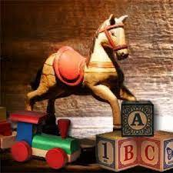
Spring 2
This term our topic is on:
‘Toys from the Past’

Guided Reading
AF1 AF2 | Use a range of strategies including accurate decoding of text,  to read for meaning
Understand, describe, select or retrieve information,
events or ideas from texts and use quotation and reference to text
English- Core texts
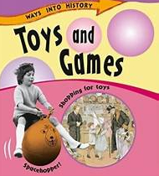
Writing Genre-

Non- Fiction: Report
- Capital letters, Full stops, Finger spaces, Adjectives, Nouns, begin to use question
Fiction: Diary entry
- Capital letters, Full stops, Finger spaces, Adjectives, Nouns, Pronoun ‘I’, Proper nouns, begin to join sentences with ‘and’ Past tense
- To explain the order of events in a story.
- To use what they have read or heard to make inferences.
- To develop fluency when reading unfamiliar texts.

PSHE: 1 Decision- Our World
- Understand how we care for others
- Understand the needs of a baby
- Be able to recognise what you can do for yourself now you are older
- Be able to describe the common features of family life
- Be able to recognise the ways in which your family is special and unique

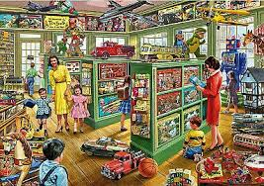

R.E: Christianity
Theme: ‘ Easter - Palm Sunday’

Key Question: Why was Jesus welcomed like a king or celebrity by the crowds on Palm Sunday?

PE – Ball Skills Hands 2
- Introduction into throwing with accuracy
- Apply throwing with accuracy in teams
- Extend throwing with accuracy

Design and Technology
Mechanism system: Making a moving storybook
- To explore making mechanisms.
- To design a moving story book.
- To construct a moving picture.
- To evaluate my finished product.

