Friday 20th March 2026
Head Teacher Message
Dear Parents and Carers,
A Vibrant Spring Term at Mayville
This spring term has been filled with energy, connection, and a renewed sense of community across the school. Our pupils have embraced new learning opportunities, taken part in exciting enrichment activities, and continued to demonstrate the kindness, curiosity, and leadership that make Mayville such a special place. Staff and families have played a huge part in shaping the team’s success, and we are grateful for the ongoing support that strengthens our school community.
🌙 Our First Mayville Iftar
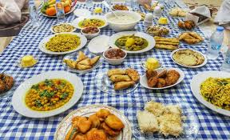
A highlight of the term was our first ever Iftar event, which brought families, staff, and friends together to share food, conversation, and reflection. It was a beautiful celebration of unity and belonging, and a powerful reminder of the richness of our school’s cultural diversity. The atmosphere was warm and joyful, with pupils proudly helping to host and explain the significance of the occasion. We give a special thank you to all of the parents and staff who worked together to make the event a success. We look forward to making this an annual tradition that continues to bring our community closer.
🚶 Community Walk with Local Councillors
We were also delighted to welcome local councillors for a community walk led by our pupils. Together, we explored the local area and visited the park to discuss the changes Mayville children would like to see—safer spaces, more inclusive play equipment, and a cleaner, greener environment. Our pupils spoke with confidence and clarity, showing real civic responsibility. Their voices were heard, valued, and taken seriously, and we are proud of the role they are playing in shaping the future of their neighbourhood.
As we bring this term to a close, we wish all of our families celebrating Iftar a wonderful Iftar celebration and also for families celebrating Easter, we wish you a fantastic Easter event.

How the Mayville Sports League is building more than champions




By Coach Charles, PE Coach

[INSERT HERO IMAGE HERE – full width across the page]

Pupils representing their teams with pride during Mayville Sports League fixtures.
Since the start of the year, the Mayville Sports League has continued to grow into something truly special. What began as a competitive house competition between our four teams - Blue Sharks, Red Dragons, Green Eagles and Yellow Lions has become a powerful platform for confidence, leadership and belonging.
Week after week, pupils have taken part in matches, skill challenges and team competitions across a range of sports. The format may change, the equipment may change, but the energy never does. Every fixture brings excitement. Every point matters.
What has stood out most, has not simply been the scores or standings. It has been the visible growth in our children. We have seen pupils who were once hesitant to join in now stepping forward to lead warm-ups. We have seen children who doubted themselves volunteering in key moments during matches.
⭐ FEATURE QUOTE
“For many children, sport is a space where they feel confident, capable and valued.”

Confidence does not always arrive with a loud celebration. Sometimes it shows up quietly in the form of a raised hand, a stronger voice, or a child choosing to try again after a mistake. Through the Mayville Sports League, those small steps have turned into giant leaps.
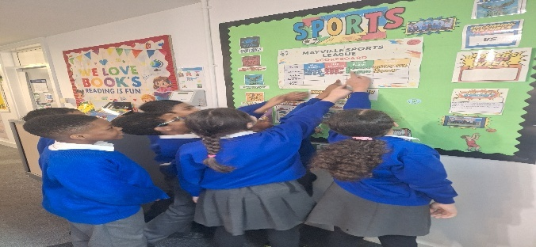

I would like to add that the idea for the Mayville Sports League was something I developed with help from Coach Rob. At the beginning, I was not entirely sure how it would be received, but it has been a real pleasure watching it grow.
Seeing children take part in sport with such enthusiasm has been incredibly rewarding. They are not just participating, they are invested. They regularly check the league standings, celebrate healthy rivalries, and step onto the pitch determined to give their all for their team.
Sport is sometimes viewed simply as a lesson in the timetable, but its impact goes far beyond that. It plays an important role not only in physical wellbeing, but in mental wellbeing too. For many children, sport is a space where they feel confident, capable and valued. It matters to them in more ways than one.

Important Dates for the diary
(Summer Term)
Event | Date | Time
George Tomlinson V Mayville friendly football match | 23.04.2026 | 1.30pm-3.30pm
Book Fair | 29.04.26-05.05.26 | Afternoons
Well-being Coffee Morning | 30.04.2026 | 9.15am-10.00am
Year 6 SATs | 11.05.26-14.05.26 | Mornings
Year 2 Assembly-Buddhism | 19.05.2026 | 9.15am
Half Term
Monday 25th May-Friday 29th May

Mayville Virtues
Autumn  Kindness | Spring  Respect | Summer  Determination

Language of the Month
Arabic
Hello- ‘mrhban’
How are you?- ‘kayf haluk’
Word of the Month
Persistent-to not give up easily


Rights Respecting
Article 28 and 29
‘Every child has the right to a good education. Governments should make sure children can get an education without it costing their family money.
Schools should respect my dignity.

Celebration Assembly
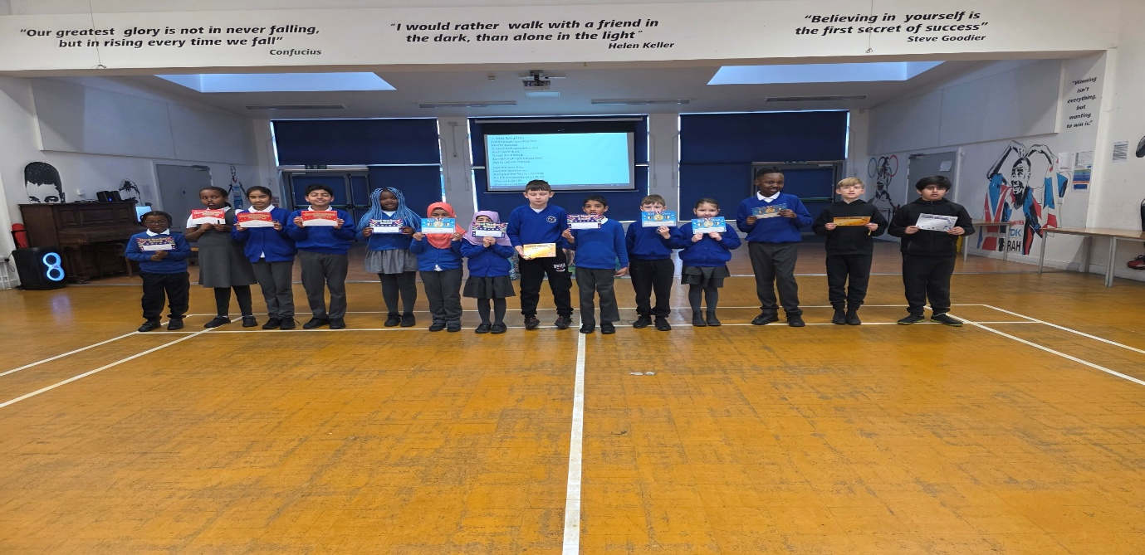

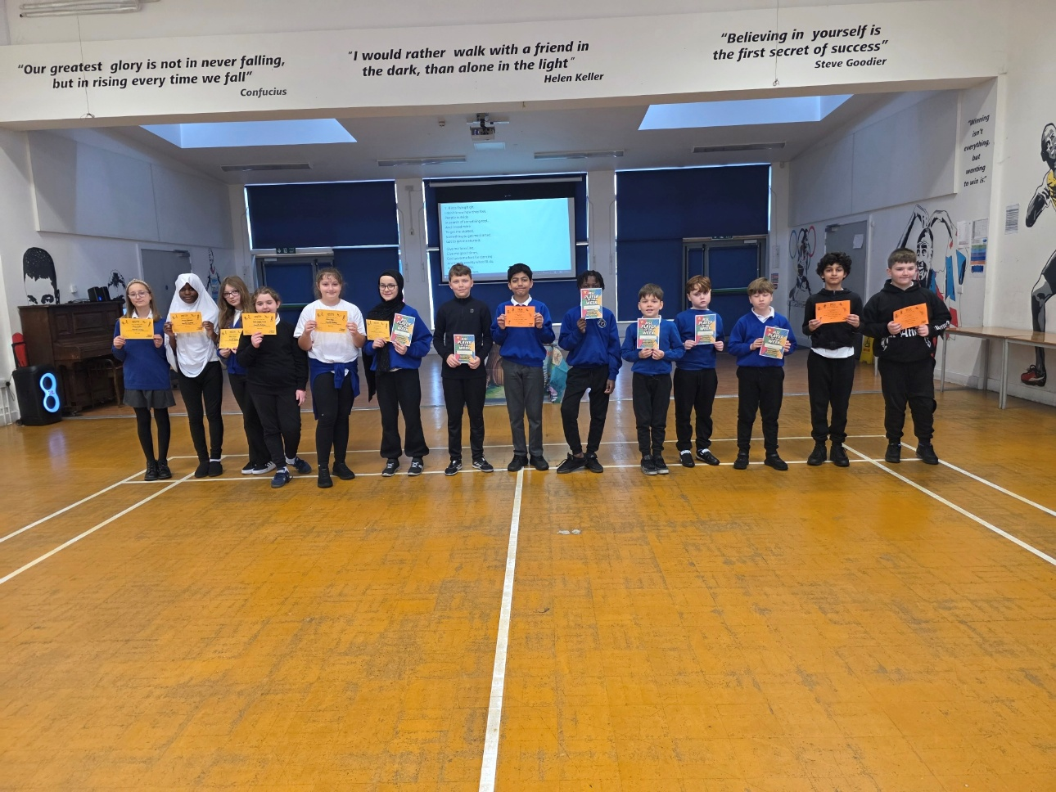

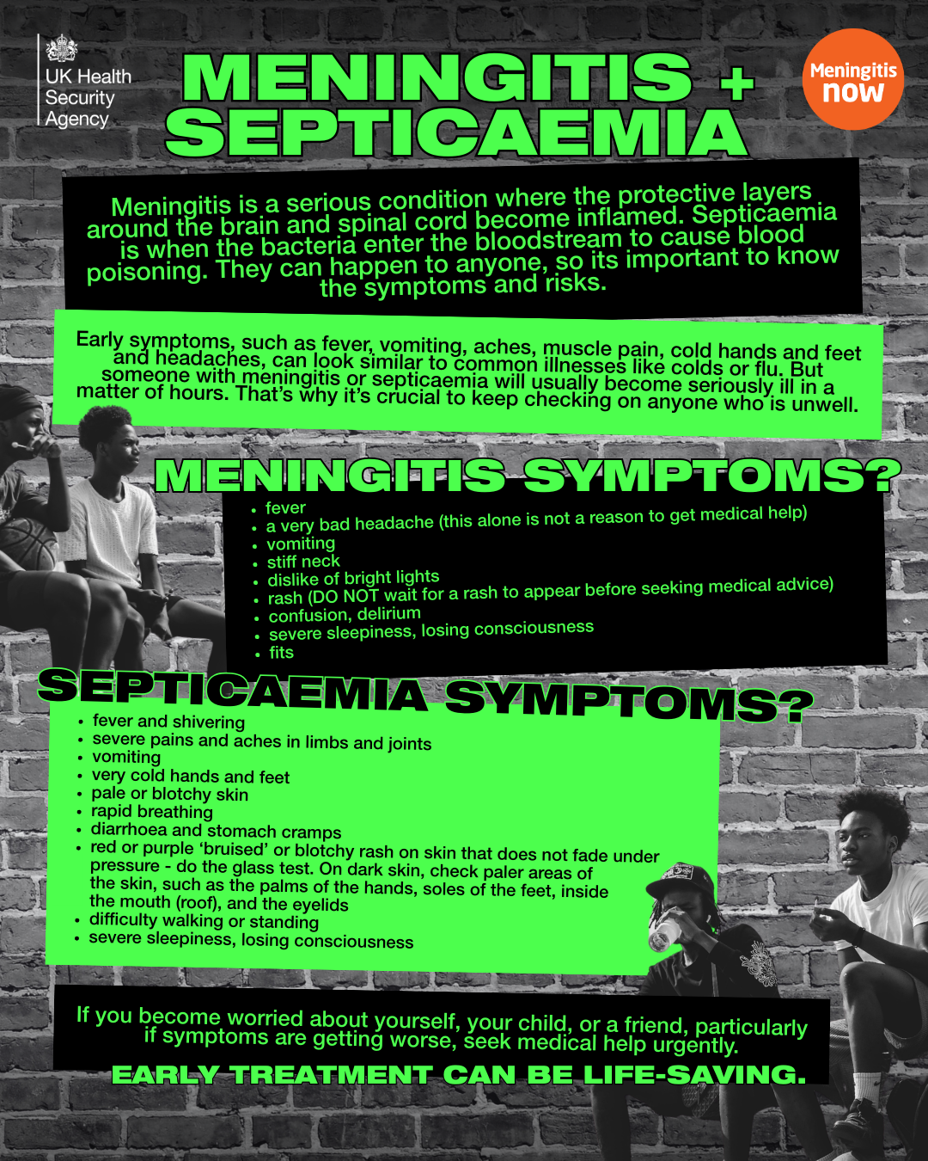

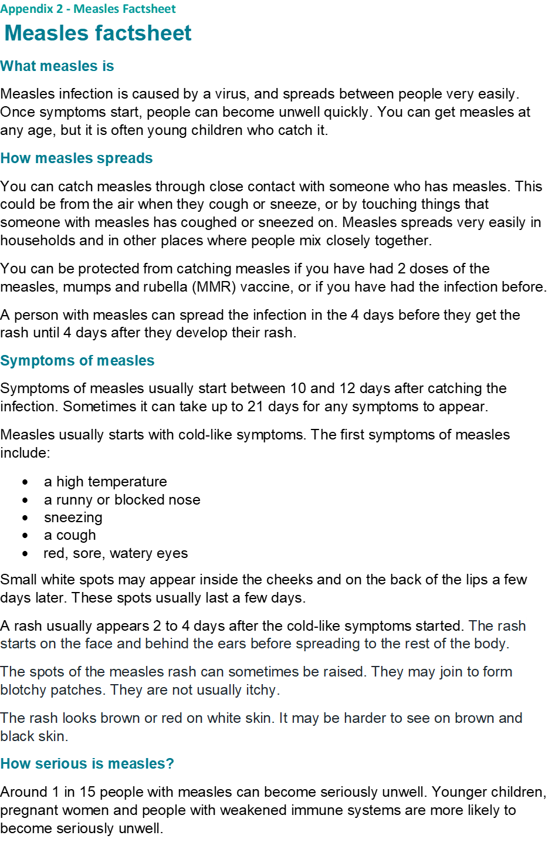Around 1 in 15 people with measles can become seriously unwell. Younger children, pregnant women and people with weakened immune systems are more likely to become seriously unwell.
The more serious complications of measles can include:
- ear infections
- lung infection (pneumonia)
- diarrhoea
- dehydration
- fits (which are less common)

Measles infection during pregnancy can result in the loss or early birth of the baby.

Preventing measles
Having the MMR vaccine is the best way to prevent measles.
The vaccine is usually given to children in two doses. The first dose is given to children aged 12 months old, and the second dose is given after they are 3 years and 4 months old.
If your child is identified as a close contact of someone with measles, sometimes your doctor may recommend the MMR vaccine is given earlier than these scheduled doses. If a dose if given to an infant aged under 12 months than the usual 2 doses of MMR still need to be given at the usual times (with a minimum of 1 month gap between any doses).
If someone has missed a dose or are unsure if they have had any vaccinations, the vaccine can be given at any age. Parents and guardians can check their child’s red book for their vaccination records.
Pregnant women or people with weakened immune systems should not have the vaccine. If they think they have had contact with someone with measles they should speak to their GP or midwife for further advice.
For more information on MMR vaccinations visit: http://www.nhs.uk/conditions/vaccinations/mmr-vaccine Or scan the QR code:

