Maths
Addition and Subtraction
- Multi-step addition and subtraction problems
- Compare calculations
- Find missing numbers

Multiplication and Division
- Multiples
- Common Multiples
- Factors
- Common factors
- Prime Numbers
- Square Numbers
- Cube numbers
- Multiply by 10, 100 and 1000
- Divide by 10, 100 and 1000
- Multiples of 10, 100, 1000
Fractions
- Find fractions equivalent to a unit fraction
- Find fractions equivalent to a non-unit fraction.
- Recognise equivalent fractions
- Convert improper fractions to mixed numbers
- Convert mixed numbers to improper fractions
History – Vikings vs Anglo Saxons
- To explore what Britain was like before the first Viking invasions.
- To find out about the Viking invasions of Britain.
- To find out about the Viking settlement of Britain and how this affected the Anglo- Saxons.
- To find out why King Alfred was dubbed ‘Alfred the Great’.
- To explore what life was like for Vikings living in Britain.
- To find out how and when England became a unified country.
- To find out about the end of the Anglo-Saxon and Viking era in Britain.

Science- Earth and Space
Recognise what the Solar System is
Know about the planets and their features
Know about the movement of the Earth and other planets in the Solar System
Explore how ideas of the Solar System have changed over time
Recognise the rotation of the Earth and how night and day occurs.
Explore the moon and its features (Step 8)

Computing: Programming music: Scratch
- Tinkering with Scratch music elements
- Sratch soundtracks – create a program that plays themed music
- Planning a soundtrack
- Programming a soundtrack
- Battle of the bands

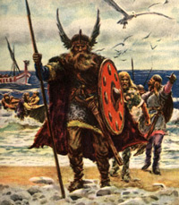
AUTUMN 2:
Vikings vs Anglo Saxons
French – Food and teastes
Values: Raising aspirations
Raising awareness of cultural differences
- -Read and understand a mini book on food and opinions p1 to 4
- Write sentences about what food I want
- Express your opinion on singular nouns for food
- Express your opinion on plural nouns for food
- Discover cultural differences through French food

Music: Blues
- History of the Blues – know the key features of Blue music
- Playing a chord – To play the first line of the 12-bar Blues
- To be able to play the 12-bar Blues
- To be able to play the Blues scales
- To be able to improvise with notes from the Blues scale

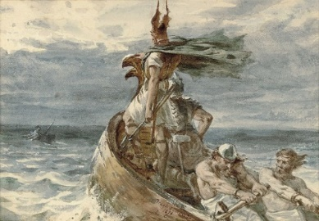


Theme: Christmas
Key Question: Is the Christmas story true?
Religion: Christianity
Concept: Incarnation
- I can start to explain how ‘true’ could mean different things to different people, and how stories can be ‘true’ in different ways
- I can start to explain the Christian belief that Jesus was the Incarnation of God.
- I can start to express an opinion on whether the Christmas story is true and what this might mean to Christians.

PSHE – Computer safety – Image sharing & Adult’s and children’s views.
- list reasons for sharing images online
- identify rules to follow when sharing images online
- describe the positive and negative consequences of sharing images online
- Recognise possible influences and pressures to share images online.

Core Book: Kick by Mitch Johnson
Writing Outcomes Non – Fiction: Persuasive letter
Fiction – Narrative a new beginning

- Recap features of a persuasive letter
- To use expanded noun phrases
- To use brackets, dashes or commas to indicate parenthesis
- To use relative clauses
- To convert nouns or adjectives into verbs using suffixes
- To use modal verbs and adverbs to indicate degrees of possibility
- To use devices to build cohesion within a paragraph
- To use a dictionary and thesaurus to edit and up-level writing
- Self/peer assessment
- Write/edit/redraft/publish

Design and Technology (D&T) – Cooking and nutrition
From farm to fork – To understand where food comes from
What does healthy look like? – To under the term ‘healthy’
Adapting and improving -= To adapt a traditional recipe
Mamma mia! What a tasty, healthy Bolognese! – To complete a food product.

P.E – Football and Handball
- refine dribbling and passing skills
- exploring basic defensive strategies and techniques
- Pupils will perform an aerobic fitness circuit developing their own aerobic fitness
- -The focus of the learning is to consolidate the pupils' understanding of handball

