Geography – Rainforests.
-To find out what a rainforest is and where they are found
- Rainforests are usually found near the equator
- The biggest rainforest in the world is the Amazon rainforest in South America.
-To explore the layers of vegetation in a rainforest.
-To investigate the climate of the rainforest.
-To find out about the people and settlements of the rainforest.
-To explore why the rainforest is under threat and the measures taken to protect it.
- Explore and research about deforestation

Maths
Multiplication and division B –
-Factor pairs / using factor pairs
-Multiply by 10, 100
-Divide by 10, 100
-Related facts – multiplication
and division
-Informal written methods for
multiplication
-Multiply a 2-digit number by a
1-digit number
-Multiply a 3-digit number by a
1-digit number
-Divide a 2-diigit by a 1-digit number x2
-Divide a 3 digit number by a
1-digit number
-Correspondence problems
-Efficient multiplication

-Multiply and divide by 7
-7 times-table and division facts
-11 times-table and division facts
-12 times-table and division facts
- multiply by 1 and 0
-Divide a number by 1 and itself
- Multiply three numbers
Science – Sound
-Recognise how sound is made and it reaches the ear
- Investigate how sounds can be measured
- Explore volume and pitch
- Plan an investigation to find out how distance from a sound affects volume
-Investigate and evaluate how distance from a sound affects volume

Length and Perimeter
-Measure in KM and M
-Equivalent lengths (km/m)
-Perimeter on a grid
- Perimeter of a rectilinear shape
--Finding missing lengths in rectilinear shapes
-calculate the perimeter of rectilinear shapes
- Perimeter of regular polygons
-Perimeter of polygons.

Computing - Creating media – Website design

-To explore the features of Google Sites to learn how to create content for a webpage
-To plan content for a web page as a collaborative online piece of work,
-To create a web page as part of a collaborative class website
-To plan and create a website
-To create a website and evaluate its success


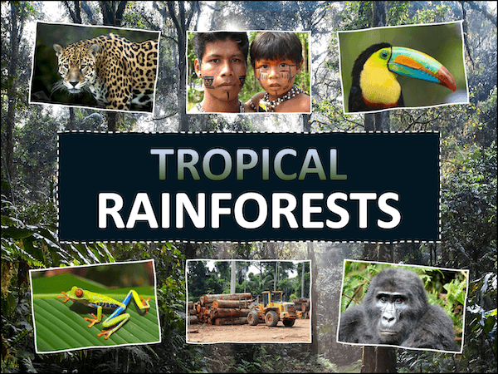
French – Clothes in France
- Clothes in France
- Clothes and colours in French
- Where do adjectives go in French
- A French clothes catalogue
- What is our French model wearing

SPRING 1
Rainforests

Music – Body and tuned percussion (Rainforests)
- To identify structure and texture in music
- To use body percussion
- Create musical rhythms using body percussion
- To create simple tunes
- To build and improve a composition

R.E – Judaism
Theme – Passover
Key Question: How important is it for Jewish people to do what God asks them to do?
-I can discuss why I would choose to follow an instruction not to eat certain foods, who I would listen to and why.
-I can describe some of the things Jews do to show respect to God.
-I can start to identify how it would feel to keep Kashrut.

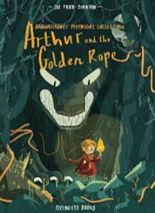
PSHE – Healthy Living
- Explain what is meant by a balanced diet and plan a balanced meal
- Recognise how too much sugar, salt, and saturated fat in our food and drink can affect us now and when we are older
- Understand nutritional information on packaged food and explain what it means
- Describe different ways to maintain a healthy lifestyle

English
Writing outcomes
- Myth Narrative (purpose- to narrate)
- Information guide (purpose- to inform)

-Grammar word: Understand the grammatical differences between plural and possessive – s, indicate possession by using possessive apostrophe with plural nous
-Grammar sentence: Expanded noun phrases, adjectives, prepositions, nouns, fronted adverbials, conjunctions
-Grammar text: Varied nouns, pronouns to avoid repetition and to add cohesion, paragraphs to link ideas around a theme.
-Grammar punctuation: Using commas after fronted adverbial.
Reading

Art - Henri Rousseu –
Theme – Rainforests
- Focus on Henri Rousseau as an artist. Observe his artwork and discuss techniques. Explore feelings, thoughts, and emotions.
- Explore techniques using inspirations artwork and develop a sketch (techniques, tints, colours, textures, shades, and tones)
- Critique and up level - Explore techniques using inspiration from Henri Rousseau artwork and develop the sketch with the focus form of media (techniques: mixing patches, colour tone and trailing on different types of paper)
- Master techniques – Creating their own version taking inspiration from the Artist.
- Evaluate techniques and compare own work with Henri Rousseau's artwork.

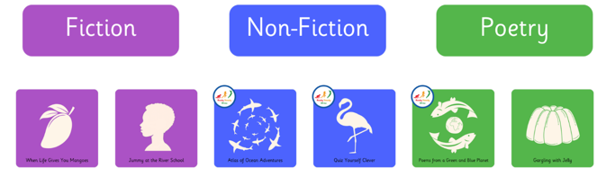
P.E
Invasion: Basketball
- The focus of the learning is to consolidate pupils' understanding of the rules of the game and how they can apply this knowledge to play in mini games.
- Children to use their prior learning of passing, dribbling and moving, to move the ball up the court, creating an attack that results in a successful shot

