Science – States of Matter
- Explore solids, liquids and gases
- Explore materials that are more difficult to categorise
- Understand how some materials can change state between solids, liquids and gases
- Investigate how temperature of water affects time takes for ice to melt
- Recognise the processes and parts of the water cycle
- Plan an experiment to investigate whether temperature affects the time it takes for water to evaporate
- Plan an experiment to investigate whether temperature affects the time it takes for water to evaporate.
History – Anglo Saxons, Picts and Scots

- To study the archaeological evidence at Sutton Hoo - to ask and answer questions.

- To find out who the Anglo-Saxons were and where they came from.

- To find out who the Picts and Scots were and where they lived.

- To be able to use various historical sources to find out about Anglo-Saxons life.

- To explore Anglo-Saxons culture including art, music, legends and poetry.

- To explore the spread of Christianity in Britain

- To use what has been discovered at Sutton Hoo – to draw conclusions about who was buried there.

Maths
Addition and subtraction
- To add and subtract 1’s, 10’s, 100’s and 1000’s
- Add up to two 4-digit numbers (no exchange)
- Add two 4-digit numbers (one exchange)
- Add two 4-digit numbers – more than one exchange
- Subtract two 4-digit numbers – no exchange
- Subtract two 4-digit numbers – one exchanges
- Subtract two 4-digit numbers – more than one exchange
- - Efficient Subtraction
- Estimating answers
- Checking strategies
Measurement – Area
-What is area?
-Count squares
-Makes shapes
-Compare areas
Multiplication and Division
-Multiples of 3
-Multiply and divide by 6
-6 times-table and division facts
-Multiply and divide by 9
- 9 times-table and division facts
-3, 6 and 9 times-table

Computing: Programming 1 – Further coding with scratch.
- Scratch reminder – To recall the key features of scratch
- Identify what code does – To understand how a scratch game works by using decomposition to identify key features
- Introduction to variables – To understand what a variable is and how to make one
- Making a variable
- To understand how to make a variable in scratch
- Times tables project – To use knowledge of how variables work to create a quiz.

-Multiply and divide by 7
-7 times-table and division facts
-11 times-table and division facts
-12 times-table and division facts
- multiply by 1 and 0
-Divide a number by 1 and itself
- Multiply three numbers


French
-Begin to describe a strange animal
-Continue to describe a strange animal
-Complete a head description rally
-Read a short text on a monster description
-Begin to write a “Wanted” poster for your monster (pair work)
-Reading and Writing Assessment
-Finish writing our “Wanted” poster for your monster (pair work)

AUTUMN 2
Anglo Saxons, Picts and Scots
Music – Rock and Roll
- Hand Jive – To understand the history of rock and roll music
- Rock around the clock – to perform with a sense of style
- Walking bass line – To play a walking bass line on tuned percussion
- Performing the bass – To be able to play a rock and roll bass line
- Rock and Roll Performance – To be able to play a rock and roll piece of music.

PSHE – Online bullying and computer Safety
- Identify positives and negatives of using computers and being online
- To understand how to keep safe online
- To identify how and who to ask for help
- To learn how to stay safe when riding a bike
- To identify risks and possible consequences of an incident
- To create a set of rules for keeping safe.

R.E – Christianity
Theme: Christmas
Key Question: What is the most significant part of the Nativity story for Christians today?
- To design a symbolic object to show the significance of Christmas or the Christmas holiday
- To describe one thing a Christian might learn about Jesus from a Christian symbol
- To ask questions about what Christmas means to Christians and compare this with what it means to me

English

Writing outcomes
- Outsider narrative
- Information report
-Grammar word: Verb inflections, plural and possessive -s and possessive apostrophes with plural nouns.
-Grammar sentence: Develop sentence structure through expanded noun phrases, fronted adverbials, and the use of prepositions to express time and place.
-Grammar text: Develop cohesion and organisation in writing through the use of nouns and pronouns to avoid repetition, and paragraphs to structure ideas around a theme.
-Grammar punctuation: Use commas after fronted adverbial.
Reading:
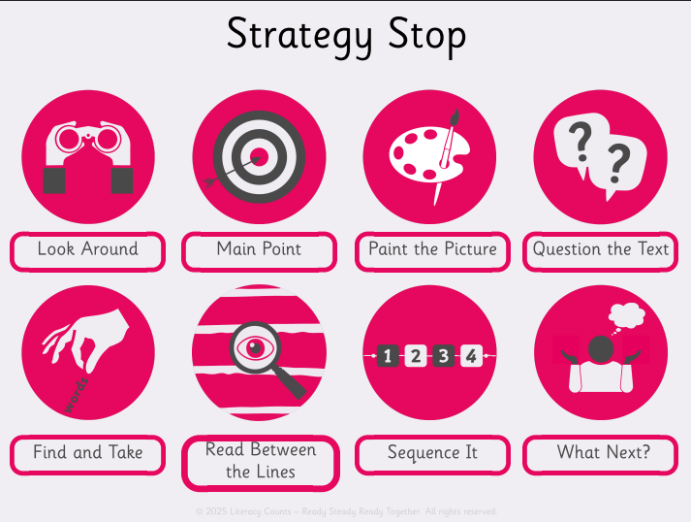

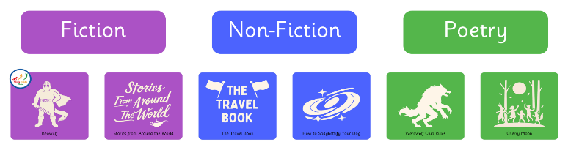
P.E – Handball and Problem Solving
- To apply passing and moving skills to keep possession
- To develop this concept into mini game situations
- To develop passing and creating space
- To explore the transition between attack and defence
- To look at what makes an effective team with the focus of cooperation and responsibility
- To focus on collaboration and communication

- Design and Technology
- Cooking and nutrition – Adapting a recipe
- Follow a recipe, with some support.
- Describe some of the features of a biscuit based on taste, smell, texture and appearance.
- Adapt a recipe by adding extra ingredients to it.
- Plan a biscuit recipe within a budget.
- Present their biscuit at the Christmas Fare!

