Geography
- To identify and locate the continents of the world.

- To explore the geographical features of each continent.

- To locate the major cities of the world.

- To research human and physical features of a country.

- To explore similarities and differences of different countries.

Science:
Nutrition and diet
- Recognise different food groups, Explore a balanced diet, Explore different kinds of diets, Explore dietary requirements of different animals
- Sustainability- Food waste
Maths
Multiplication and Division
- Recaping 3, 4, and 8 times tables
- Comparing multiplication statements
- Multiplying and dividing by 10
- Multiplying by multiples of 10 (30, 50, 60 etc)
- Multiplying 2 digit numbers by 1 digit numbers
- Dividing 2 digit numbers using mental strategies.
- Dividing using short division
- Solving reasoning problems relating to these strategies.

Length and Perimeter
-Comparing , adding and subtracting lengths.
-Measure and calculate perimeter.
-Measure in cm, mm and m.
-Learn about equivalent lengths.

Computing: Emails

- To identify how to send emails to others.
- To know how to add attachments to an email
- To recognise the importance of sending positive emails and being kind online
- To know how recognise fake or unsafe emails
- To recognise what cyberbullying is.

Year 3 - Spring 1
Countries of the world

French: The date and celebrations
-Make links between some phonemes, rhymes and spellings-Observe a French calendar-Read the names of the days of the week-Place the days in chronological order-Learn a nursery rhyme with the days

Music: Singing pitch and rhythm.

- To use musical language to describe feel of the music.
- To improve accuracy in pitch and control, singing with expression and dynamics
- To identify the patterns and repeating themes of a song.
- To sing as a part of a group in order to sing in rounds.
- To keep beat alongside a song.

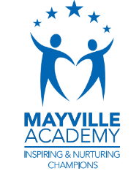
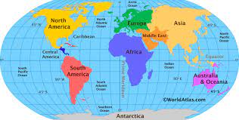

Writing

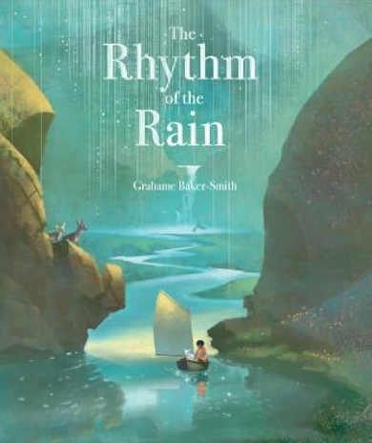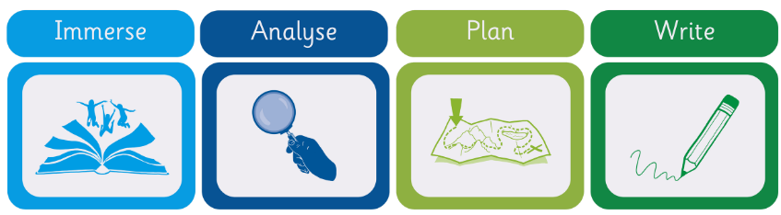
Guided Reading

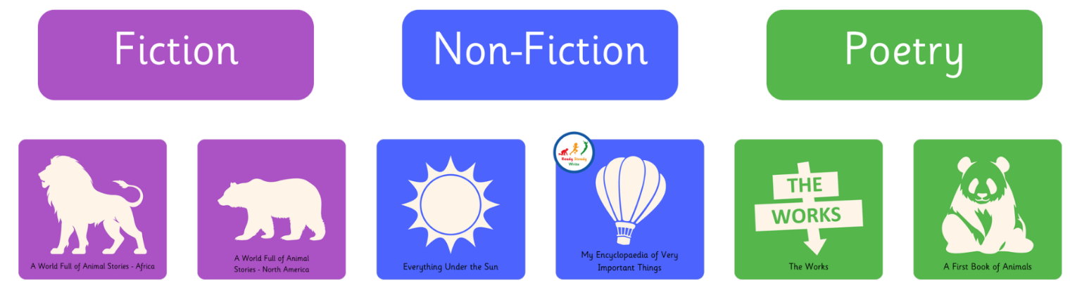
PSHE: Staying Healthy

-To understand what we can do to keep healthy
–To understand why we need to wash our hands
- To know how germs are spread and how they can affect our health
-To be able to practise washing your hands
-To know the differences between healthy and unhealthy choices

R.E: Christianity
Theme: Miracles
Concept: Incarnation
Key Question: Could Jesus heal people or is there another explanation?
- To explore how people define miracles and what makes something miraculous..
- To explore the story of Jesus healing the blind man. How do we heal people these days?
- To reflect on my own beliefs about whether miracles can occur and why people believe in them.

P.E
Invasion: Basketball
- The focus of the learning is to consolidate pupils' understanding of the rules of the game and how they can apply this knowledge to play in mini games.
- Children to use their prior learning of passing, dribbling and moving, to move the ball up the court, creating an attack that results in a successful shot

Art
Skill- Painting – shading and charcoal.
Inspirational Artist- Wayne Thiebaud

- To take inspiration from others. Look at different historical and modern sketches.
- To develop shading techniques: shading light and dark tones on a drawing to add detail.
- To master techniques: Create different materials such as charcoals, shades, and tones of different colours with pencils and charcoal.
- To evaluate techniques and compare.

