Science:
Nutrition and diet
Recognise different food groups, Explore a balanced diet, Explore different kinds of diets, Explore dietry requirements of different animals
Sustainability- Food waste
Rocks
Identify and group rocks, test rocks

History- Stone Age –Iron Age

LO: To use historical enquiry to find out survival in prehistory.
I can infer purpose of artefacts with some justification.
I can infer how life must have been based on these sources.
I can ask questions about a historical sources.
L0: To compare Neolithic and Palaeolithic lives.
I can understand how the Stone Age changed over time.
I can recognise the invention of farming as a key factor into our lives.
I can refer to Skara Brae as an example of Neolithic settlements and compare that to Palaeolithic survival.
L0: To use historic sources to compare Stone Age to Bronze Age
I can recognise the differences and similarities between artefacts in Stone Age and Bronze Age.
I can give reasons as to why people changed over time.
I can infer as to how these changes changed Britain with through to modern life.
.LO: To understand the lives of Iron Age people
I can recognise the jobs of the Iron Age settlements
I can compare jobs of Iron Age to modern day.
I can recognise some differences between Stone, Bronze and Iron Age.

Maths
Addition and Subtraction
-Add and subtract 1s, 10s and 100s crossing over
- Add and subtract two numbers without exchange
- Add and subtract two numbers with exchange
-Add and subtract 2-digit numbers from 3-digit numbers
-Estimate answers and use the inverse operation
Multiplication and Division
-Recognise multiplication as equal groups and use arrays
-Recognise multiples of 2, 5 and 10
- Recognise sharing and grouping
-Multiply and divide by 3, 4, 8
-Consolidate 3, 4 and 8 times-tables

Computing: Programming: Scratch
-To explore a programming application.
-To use repetition (a loop) in a program.
-To program an animation.
-To program a story.
-To program a game.

French: My Body
-To locate and name French speaking countries, parts of the body, simple adjectives, animals, high frequency verbs

Music: Creating a composition in response to an animation

- Telling stories through music
- Creating a soundscape
- Story sound effects
- Adding rhythm
- Musical mountain


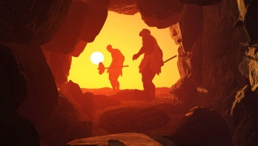
Year 3
Autumn 2
This term our topic is on:
Stone Age –Iron Age

PSHE: 1 Decision- Computer Safety /Keeping Safe
-To be able to identify possible dangers and consequences of talking to strangers online
-To know how to keep safe in online chatrooms
-To be able to name the positives and negatives of using technology
•To understand the difference between safe and risky choices online

R.E: Christianity
Believing
Theme: Christmas
Concept: Incarnation
Key Question: Has Christmas lost its true meaning?
Religion: Christianity
Writing

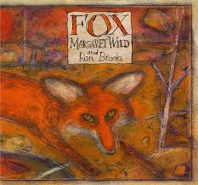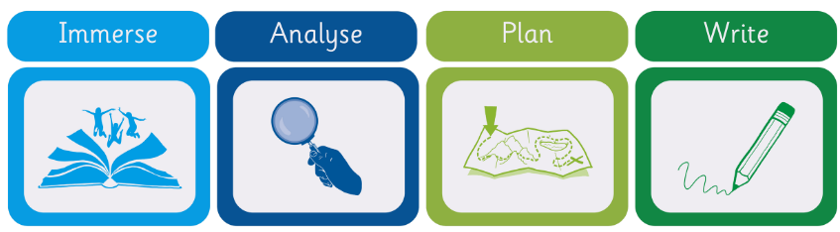
Guided Reading

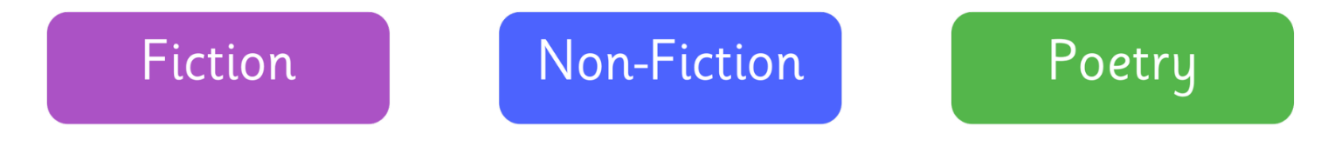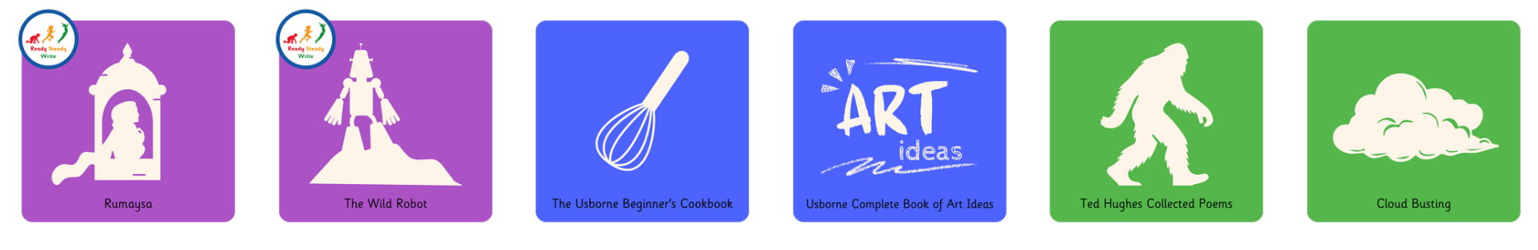

Design and Technology
Structures: Constructing a castle
-To recognise how multiple shapes (2D and 3D) are combined to form a strong and stable structure.
-To design a castle
-To construct 3D nets
-To build a castle
P.E- Invasion: Handball
-Handball Introduce passing, receiving and creating space Develop passing and moving
-Combine passing and moving Introduce shooting Develop passing and shooting

