Maths

Shape
- To recognise 2D shapes.
- To know the properties of 2D shapes.
- To recognise 3D shapes.
- To know the properties of 3D shapes.
- To identify the line of symmetry.
- To compare similarities and differences of 2D and 3D shapes.

Measurement- Money
- To identify UK coins and notes.
- To count money.
- To make an amount in different combinations.
- To find change.

Geography India
- To explore India and where it is in the world.
- To explore the mountain ranges found in India.
- To know some of the major rivers in India.
- To explore the human and physical features of cities in India.
- To explore India’s culture and its influence on other countries.
- To compare India to the United Kingdom.
Science: ‘Plants’
Bulbs, seeds, plants
- To investigate what a seed is.
- To understand the process of germination.
- To explore what seeds need to germinate.
- To understand what growth is.
- To explore what seeds need to grow.
- To understand that most plants make fruits or vegetables.

Computing:
Computing Systems and Networks: Word Processing
- Explain which the home row keys are and how to find them for typing.
- Use the spacebar and backspace correctly.
- Type and make simple alterations to text using buttons on a word processor.
- Search for, import and alter appropriate images for a text document.
- Modify text in a document.
- Use copy and paste to copy text from one document to another.
- Explain what information is safe to be shared online.

Music: Musical me
- Clap the rhythm of their name.
- Sing the melody accurately while playing their instrument in time.
- Show a range of emotions using their voices.
- Describe the dynamics and timbre of their pieces.
- Play a known melody from letter notation in the right order, if not with the right rhythms.
- Invent a melody, write it down and play it back.

`
PSHE: 1Decision- Keeping healthy and staying safe
- To understand what we can do to keep healthy.
- To understand that food is needed for our bodies to be healthy and grow.
- To understand how to keep ourselves and others healthy.
- To understand the differences between healthy and unhealthy choices.
- To practise brushing your teeth.




English
Writing outcomes
- Finding Narrative – Purpose to narrate
Grammer word – using suffix -full, ness
Grammer sentence – subordinate clause, co-ordination, expanded noun phrase
Grammer text – past and present tense
Grammer Punctuation – capital letter, full stop, question mark, commas and apostrophes

Reading
Spring 1
This term our topic is on:
India

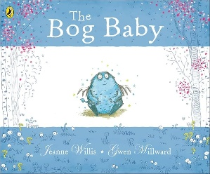

R.E: Islam
Theme: ‘Prayer at Home’
Key Question: Does Praying at regular intervals help a Muslim in his/ her everyday life?

PE – Invasion: Ball skills /Dance

- The focus of learning is to develop dribbling in order to keep possession of the ball.
- To combine dribbling, passing and receiving using out feed in order to keep possession of the ball.
- To combine dribbling, passing and receiving in order to keep possession and score a point.
- To apply their knowledge as a team.


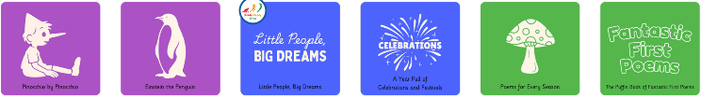
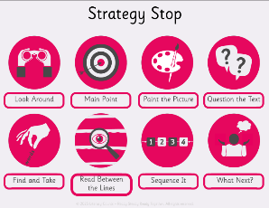
Art: India
Inspirational Artist- Paul Cezanne
- To take inspiration from others. Look at artwork from Paul Cezanne.
- To develop ideas: Sketch the drawing of the selected biome: tints, shades, tone
- To master techniques: Create different tints, shades, and tones of different colours acrylic paint
- To evaluate techniques and compare.

