Science: Biology
HEALTHY ME: Animals and humans.
- To explore animals including humans and their offspring
- To explore the basic needs of animals, including humans
- To understand what makes a healthy meal and
- To be able to sort food into food groups
Geography – Seas and coasts

Location Knowledge • I can locate the main oceans and continents.
Place Knowledge • I can find out about the United Kingdom, the countries that it includes and its geographical location in the world.
Human and Physical Geography • I can name and locate human and physical features when looking at different British beaches • I can compare British and non-British beaches. • I can describe how seas in Britain are different to seas in other countries
Geographical skills and fieldwork • Use a compass rose to locate the seas around the UK • I can describe the main oceans that surround UK

Maths

Place Values
• To recap from year 1
• To represent numbers to 100
• To using a place value chart
• To add using tens and ones
• To order objects and numbers
• To count in 5’s, 10’s and 3’s

Addition and Subtraction
• To recap number bonds to 10
• To learn bonds to 100 - tens
• To add and subtract 1’s
• To know 10 more & 10 less

Computing: Computing: System Network

- To recognise parts of a computer
- To recognise how technology is controlled.
- To understand the role of computers.
- To develop word processing skills, including altering text, copying, pasting and using keyboard shortcuts.

Guided Reading
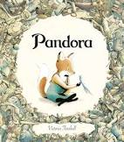
Learning Objectives - To work out the meaning of new vocabulary. To use new vocabulary to understand a text. To discuss characters and events in a story.
Writing
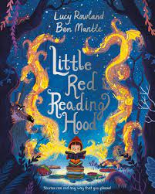
Core Text: Little Red reading hood
Fiction: Short narrative – retell the story
Fiction: Postcard
Grammar Focus
- Capital letters
- Full stops
- Finger spaces
- Past tense
- Noun phrases
- Pronoun ‘I’

Year 2- Autumn 1
This term our topic is on:
Seas and coasts
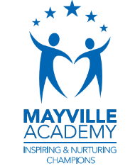
Music:
African call and response song - Theme: Animals
- To create short sequences of sound.
- To copy a short rhythm and recognise simple notation.
- To learn a traditional song from Ghana
- To create rhythms based on ‘call and response’
- To add dynamics (volume) to a structure of rhythms

R.E: Christianity
Theme: What did Jesus teach? Key Question: Is it possible to be kind to everyone all of the time?
Lo- I can tell you when I have been kind to others even when it was difficult.
Lo- I can re-tell a story Jesus told about being kind or give an example of when Jesus showed kindness.
Lo-I can say if I think Christians should be kind and give a reason.

PSHE: 1 Decision-Feelings and Emotions
- To understand a range of emotions and how they make us feel physically and mentally.
- To be able to recognise and name emotions and their physical effects.
- To know the difference between pleasant and unpleasant emotions.
- To learn a range of skills for coping with unpleasant/uncomfortable emotions.
- Understand that feelings can be communicated with and without words.

Art- Collage-Inspirational Artist- Jesse Treece
- Focus on inspirational artist, observe artwork and discuss techniques. Explore feelings, thoughts and emotions.
- Explore techniques using inspirations artwork and design and initial idea. Create a collage using various textiles and media.
- Critique and up level- Explore techniques using inspirations art work and develop the sketch with the focus form of media( techniques: mixing patches, colour tone and trialling on different types of paper)
- Master and evaluate techniques- Creating their own version taking inspiration from the Artist.

PE – Locomotion: Dodging & creating games: Linking
- To explore dodging and learn how to dodge effectively.
- To develop pupils’ dodging technique applying this into games.
- The focus of the learning is for pupils to work together in groups and teams to create and play game
- Pupils will develop an understanding of how to play by the rules and how to cooperate with others, as well as winning, losing and drawing when we play competitive games.

