 | Gross Motor | Fine Motor
Physical Development | - Start taking part in some group activities which they make up for themselves, or in teams  -Skip, hop, stand on one leg and hold a pose for a game like musical statues. | -Uses a comfortable grip with good control when holding pens and pencils.  -Show a preference for a dominant hand.
 | Listening and attention | Speaking
Communication and Language | Enjoy listening to longer stories and can remember much of what happens.  • Can find it difficult to pay attention to more than one thing at a time | Develop their communication, but may continue to have problems with irregular tenses and plurals, such as ‘runned’ for ‘ran’, ‘swimmed’ for ‘swam’.
 | Self-Regulation | Managing self | Building relationships
Personal, social, emotional development. | -Is developing his/her sense of responsibility and membership to a community  -Helps find solutions to conflicts and rivalries | -Is increasingly independent in meeting their own care needs, e.g., brushing teeth, using the toilet, washing and drying their hands thoroughly | Play with one or more other children, extending and elaborating play ideas.

 | People and Communities | Natural World | Past and Present
Understanding the world | Shows interest in different occupations | -Talks about what he/she sees, using a wide vocabulary | Begin to make sense of their own life-story and family’s history

 | comprehension | Reading | Writing
Literacy | -Engages in extended conversation about stories, learning new vocabulary | -Understand the five key concepts about print:  - print has meaning  - the names of the different parts of a book  - print can have different purposes - page sequencing  - we read English text from left to right and from top to bottom. | -Write some or their entire name.
 | Creating with materials | Being Imaginative and Expressive
Expressive arts and design | Can create closed shapes with continuous lines, and is beginning to use these shapes to represent objects | -Is beginning to develop complex stories using small world equipment like animal sets, dolls, and dolls houses etc.
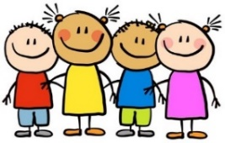
Nursery Medium Term Plan
This term our topic is on:
People Who Help Us
Spring1

 | Number | Numerical patterns
Mathematics | - Know that the last number reached when counting a small set of objects tells you how many there are in total (‘cardinal principle’).  -Can show ‘finger numbers’ up to five | -Discuss routes and locations, using words like ‘in front of’ and ‘behind’  -Make comparisons between objects relating to weight and capacity


Joy of learning | Week 1  Vets | Week 2  Police | Week 3  Firefighters | Week 4  Doctors | Week 5  Doctors/Dentist | Week 6  Doctors/Dentist
Focus Books | 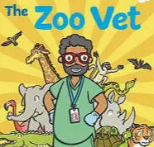  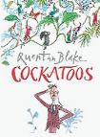 | 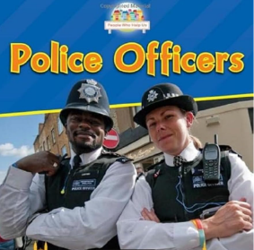  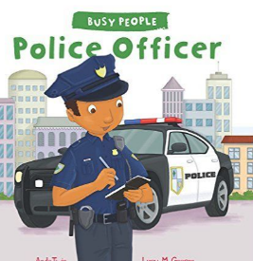 | 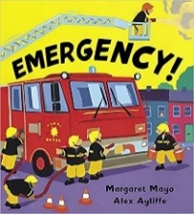  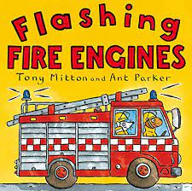  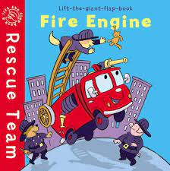 | 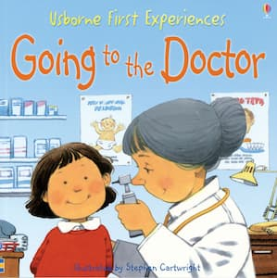
Nursery activities: | PDES/EAD-  British Values- respecting the belief, differences and the feelings of others.  Look at non-fiction books about people that help us.  Maths- Shapes  Shape exploration  Shape making and matching  Whiterose- numbers, shape, measure. Literacy: name badges-Vets. Pencil control skills.  UW-Vets role play, people that help us investigation.  Role Play- Vets surgery. | PSED-Introducing class-based monitor jobs for children.  Maths- police song (counting on fingers)  Puzzles and shapes  EAD-Joining in with repeated refrains.  Police role- play.  Model language through role-play using various tenses.  UW- Building little worlds  Literacy- Reading police texts.  Writing down a wanted poster.  Role Play-Police station. | Literacy: Reading firefighter texts  Writing down emergencies  Maths: Shapes in a fire engine  UW/PSED- Building little worlds  Fire fighters/dentist/police visiting the school  EAD- Model language through role-play using various tenses.  Role Play- Fire station | UW/EAD- Links with celebrating uniqueness  Chinese New Year- British values  Look at different countries-where is China? Have a map on display with pictures of Chinese artefacts.  Literacy-Making lanterns/Chinese letters –calligraphy.  Feelings and mirrors.  Maths: Positional language with the doctors and teddies  Role Play- Doctors | PSED/UW-  Discovering how doctors help us  Fire station trip  UW-  What questions will doctors ask?  EAD— Colouring different parts of the body  Maths- Doctors puzzles and shapes  Lit/PSED- Talk about how we can solve problems, solutions to take turns with the doctor’s play  Role Play- Doctors | PSED/UW-  Visiting a doctor’s surgery  Visit from a dentist  UW-  What questions will a dentist ask?  EAD— Making a mouth with healthy teeth  Maths- Bigger and smaller sorting  Lit/PSED- Talk about healthy choices e.g. Brushing teeth  Role Play- Doctors
Lit | Daily name writing  Daily nursery rhymes and music sessions  Selection of information books about people that help us | Daily name writing  Daily nursery rhymes and music sessions  Selection of information books about people that help us | Daily name writing  Daily nursery rhymes and music sessions  Selection of information books about people that help us | Daily name writing  Daily nursery rhymes and music sessions  Selection of information books about people that help us | Daily name writing  Daily nursery rhymes and music sessions  Selection of information books about people that help us
PD | Fine motor: colouring, cutting, tracing, painting.  Gross motor: yoga, hopscotch, chubby chalks outside, dancing, yoga, rolling cars, painting. | Fine motor: Painting, writing, playdough  Gross motor skills- Yoga, dancing, bikes, big blocks. | Fine motor: Cutting, gluing, painting, writing  Gross motor skills- Yoga, dancing, bikes, big blocks. | Gross motor: Yoga, dancing, bikes, big blocks.  Fine motor: colouring, cutting, tracing, painting, using tweezers | Gross Motor: Hop or stand on one leg and hold a pose for the dragon dances. Yoga, dancing, bikes, big blocks.  Fine motor- playdough, colouring, gluing

