Science: ‘Materials’

- To explore common materials and rocks
- To explore the difference between objects and materials
- To explore melting and freezing
- To explore which materials float, sink and absorb water
- To investigate which materials is best for curtains
Seasonal changes:
- Autumn
- Winter
History

- To explain what Bonfire Night is
- To find out about King James I of England
- To find out who Guy Fawkes was
- To find out what happened next in the Gunpowder Plot
- To think about why fireworks are lit on November 5th
Maths

- Addition and Subtraction (within 10)
- To learn the part whole model.
- To learn about number facts and the addition symbol.
- To learn about adding and subtraction one digit numbers.
- To learn the correct vocabulary for addition and subtraction.
- Geometry: Shape
- Recognise and name 3D shapes
- Sort 3D shapes
- Recognise and name 2D shapes
- Sort 2D shapes
- Patterns with 2D and 3D shapes
- Place value within 20
- Counting forward and backwards and write numbers to 20

Computing: Algorithm Unplugged

- To understand what is an algorithm is
- To follow instructions precisely to carry out an action when creating algorithm pictures.
- To understand and be able to explain what decomposition is.
- To know how to debug an algorithm.
Music:
Classic music, dynamics and tempo: animals.
- Percussive animals
- Singing animals
- Performing animals
- Composing animals
- The story of the lion

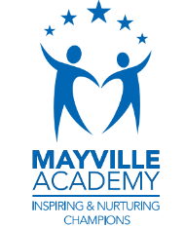
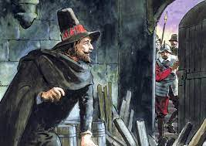
Autumn 2
This term our topic is on:
Gunpowder plot

PSHE: 1 Decision-Computer Safety
- To understand computers, the internet, and rules to keep safe
- To sing a song in sections
- To know who and how to ask for help
- To be able to recognise kind and unkind comments.

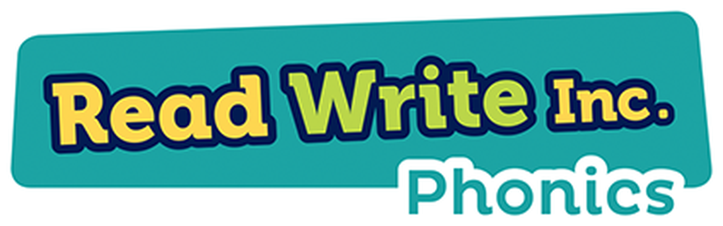
Guided Reading
AF1 | Use a range of strategies including accurate decoding of text,  to read for meaning
AF2 | Understand, describe, select or retrieve information,  events or ideas from texts and use quotation and reference to text  Literacy- Core texts
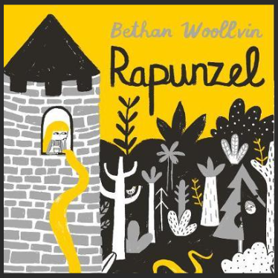
English: Rapunzel

Writing Genre- Non- Fiction – narrative

- Say out loud what they are going to write
- Write a basic sentence
- Nouns- begin to understand that nouns have a capital letter
- Correct formation
- Capital letters, full stops
- Exclamation marks
- Question marks

R.E: Christianity
Theme: ‘Christmas’
Key Question: What gifts might Christians in my town have given Jesus if he had been born here rather than in Bethlehem?
- I can talk about a gift that is special to me. (Engagement)
- I can remember some of the Christmas story. (Investigation and Evaluation)
- I can suggest a gift I would give to Jesus. (Expression)

PE – Dance
- The focus of the learning is for pupils to create a range of controlled movements that represent a superhero.
- Pupils will perform a range of controlled movements that demonstrate their superheroes' superpowers.
- The focus of learning is for pupils to create movements that represent a real life hero.

Design and Technology
- Learn to distinguish between fruit and vegetables.
- Explore where fruits and vegetables grow and where edible part of the plant grow on trees or vines, above the round or under the soil and which part of it do we eat.
- Smoothie and ingredient tasting.
- Making Smoothies.
- Assessment quiz and knowledge catcher.

