Maths

Place Value
- Count forward to backwards and write numbers to 20 in numeral and word form
- Numbers 11-20, Numbers to 50
- Tens and Ones
- Count one more and one less
- Compare groups of objects
- Compare numbers, order groups of objects, and order numbers

Science: ‘Animals’
- To Identify and name a variety of animals including fish, birds, mammals, amphibians and reptiles.
- To ask questions and recognise they can be answered in different ways.
- To work scientifically and make observations.
- To identify and classify.

Geography
- To find out how the seasons are linked to the months of the year.
- To find out what the weather is like in spring.
- To find out what the weather is like in summer.
- To find out what the weather is like in autumn.
- To find out what the weather is like in winter.
- To review knowledge and compare the four seasons.

Computing: “Algorithms unplugged”
- What is an Algorithm
- Algorithm pictures
- Virtual assistants
- Step by step
- Debugging

Additionally to this topic children will complete an e safety lesson.
Music: ‘musical vocabulary –under the sea’
- To learn the musical vocabulary- pulse and tempo.
- To explain what dynamics and timbre are.
- To explain what pulse and rhythm are.
- To explain what texture and structure are
- To understand key musical vocabulary: dynamics, pitch, pulse, rhythm, structure, tempo, texture, timbre

PSHE: 1 Decision- Keeping healthy and staying safe
- To understand what we can do to keep healthy.
- To understand why we need to wash our hands.
- To know how germs are spread and how they can affect our health.
- To be able to practise washing your hands.
- To know the differences between healthy and unhealthy choices.

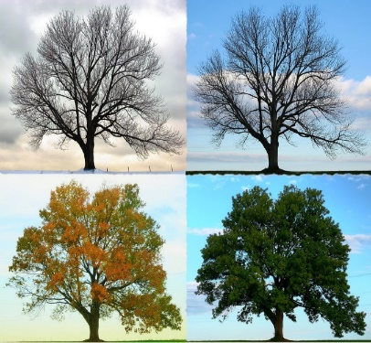



Spring 1
This term our topic is on:
The Four Seasons

- To identify and review Set 1-3
- To sound out Set 1-3 Sounds in words
- To spell words using Set 1-3 sounds
Reading for enjoyment:
- Read and understand a range of texts, including stories, rhymes and non-fiction.
- Identify and discuss the main events, characters and themes in a story.
- Predict what will happen next in a story.
- Build on vocabulary.

PE –Invasion: Ball skills /Dance
- The focus of learning is to develop using our feet to move with a ball.
- The focus of learning is to apply dribbling with our feet into games.
- The focus of learning is to consolidate pupils understanding of where to dribble and why.
- The focus of learning is to explore kicking (passing) a ball.
- The focus of learning is to develop pupils kicking (passing) technique applying this into a game to score points.
R.E: Christianity
Theme: ‘Jesus as a friend’
Key Question: Was it always easy for Jesus to show friendship?

English
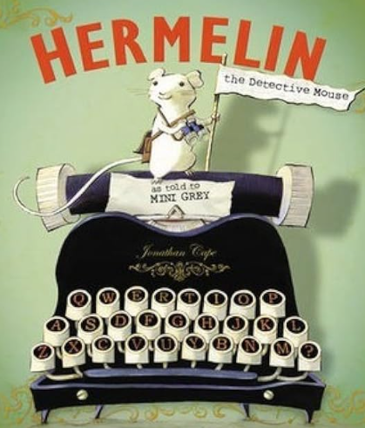
Children will be reading and reviewing features of a non-fiction piece of writing. They will be able to identify:
- What a non-fiction text is.
- What an information text looks like.
- Features of an information text.
- Rewriting their own information text.
Art: Skill- Painting
Inspirational Artist- Jean Metzinger

- To take inspiration from others. Look at artwork from Jean Metzinger.
- To develop ideas: Sketch the drawing of the selected biome: tints, shades, tone
- To master techniques: Create different tints, shades, and tones of different colours acrylic paint
- To evaluate techniques and compare.

