Geography

- To use a range of sources to research and write about a natural disaster in history.
- To use map skills to identify geographical features
- To investigate geographical processes.
- To use map skills to locate different types of volcanoes.
- To explain the distribution of natural resources.
- Name and locate the key topographical features including coast, features of erosion, Hills Mountains and rivers. Understand how these features have changed over time.
- Describe and understand key aspects of physical geography: Volcanoes, earthquakes, plate tectonics. Distribution of natural resources focusing on energy.
- Use maps, atlases, globes and digital mapping (Google Earth) to locate countries and describe features studied. To use a range of sources to research and write about a natural disaster in history.
- To use map skills to identify geographical features
- To investigate geographical processes.
- To use map skills to locate different types of volcanoes.
- To explain the distribution of natural resources.
- Name and locate the key topographical features including coast, features of erosion, Hills Mountains and rivers. Understand how these features have changed over time.
- Describe and understand key aspects of physical geography: Volcanoes, earthquakes, plate tectonics. Distribution of natural resources focusing on energy.
- Use maps, atlases, globes and digital mapping (Google Earth) to locate countries and describe features studied.
- On a world map locate the main countries in Africa, Asia and Oceania. Identify the main environmental regions, key physical and human characteristics and major cities.

- On a world map locate the main countries in Africa, Asia and Oceania. Identify the main environmental regions, key physical and human characteristics and major cities.

Science: Light
- To recognise that light appears to travel in straight lines.
- To use the idea that light travels in straight lines to explain that objects are seen because they give out or reflect light into the eye.
- To explain that we see things because light travels from light sources to our eyes or from light sources to objects and then to our eyes.
- To use the idea that light travels in straight lines to explain why shadows have the same shape as the objects that cast them.
Maths
Angles
- Angles on a straight line
- Angles on a point
- Angles in a triangle, quadrilateral
- Opposite angles

Measurement
- Conversion units of length, mass, capacity and time
Coordinates
- Plotting coordinates in all four coordinates
- Finding missing coordinates

Area
- Finding the area of quadrilateral, compound shapes

Perimeter
- Finding the perimeter of quadrilateral, compound shapes
Calculate the volume
- Find the missing side of a cuboid and prism

Transformation – translation and reflection

Computing: Big Data 1

- To identify how barcodes and QR codes work
- To know how infrared waves transmit data
- To recognise the uses of RFID
- To know how encoding keeps data safe
- To gather and analyse data in real time
- To analyse and evaluate data

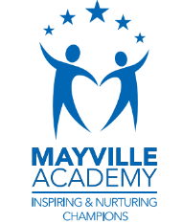
Music: Film Music
- To appraise different musical features in a variety of film contexts
- To identify and understand some composing techniques in film music
- To use graphic scores to interpret different emotions in film music
- To create and notate musical ideas and relate them to film music
- To play a sequence of musical ideas to convey emotion

Spring 1
This term our topic is on:
Extreme Earth
French: In my house
- To describe houses in French
- To write a description of a house in French
- To use prepositions to describe the position of items in the bedroom
- To use prepositions to describe the positions of objects in the bedroom
- To write a letter describing my home

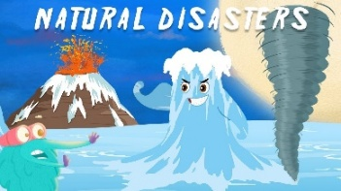

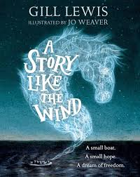
PSHE: 1 Decision
Keeping and staying safe: Alcohol and drugs

- Discuss when and why people drink alcohol
- Identify the risks associated with alcohol (+ drugs - extension)
- What affects can alcohol have on your body?
- Describe how alcohol can affect your immediate and future health
- Develop and recognise skills and strategies to keep safe

English

Writing outcomes
- Flashback Narrative (purpose- to narrate)
- Newspaper Report (purpose- to report)

-Grammar word: Informal and formal speech; synonyms and antonyms, using suffixes e.g. -ate, -en, -ify and -ise.
-Grammar sentence: Informal and formal speech; expanded noun phrases to convey complicated information concisely.
-Grammar text: Linking ideas within and across paragraphs using adverbials.
-Grammar punctuation: Using semi-colons to mark boundary between independent clauses; hyphens to avoid ambiguity.
Reading

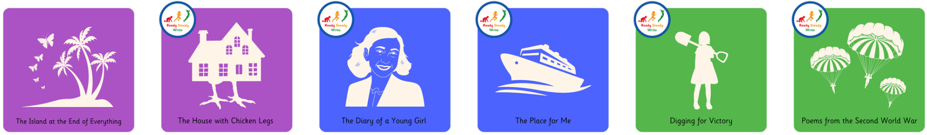

R.E: Christianity
Theme: Beliefs and Meaning
Concept: Salvation
Key Question: Is anything ever eternal?
- To express the feelings I have when I think about situations or things I would like to last forever.
- To make links between different Christian beliefs and their views on whether anything is ever eternal.
- To reflect on my own beliefs about whether anything is eternal.

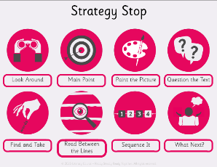
P.E
Invasion: Basketball
- The focus of the learning is to consolidate pupils' understanding of the rules of the game and how they can apply this knowledge to play in mini games.
- Children to use their prior learning of passing, dribbling and moving, to move the ball up the court, creating an attack that results in a successful shot

Art
Skill- Painting – Acyrlic and canvas
Inspirational Artist- Stephanie Peters

- Look at different Natural Disasters artwork created by Stephanie Peters
- To develop ideas: Sketch the drawing of the selected natural disasters expressing emotions and feelings: tints, shades, tone, bright colours
- To master techniques: Create different natural disasters using acrylic, string and threat to stitch back together
- To evaluate techniques and compare.

