Science: Electricity

- To construct and draw series circuits using symbols
- To explore complete and incomplete circuits
- To explore variations within circuits
- To plan an experiment on voltage
- To carry out an experiment on voltage
- To evaluate the experiment on voltage
- To record data and results using scientific diagrams
- To plan different types of scientific enquires to answer questions
Maths
Fractions, decimals and percentages
- Use written division methods in cases where the answer has up to two decimal places.
- Solve problems which require answers to be rounded to specified degrees of accuracy.
- Recall and use equivalences between simple fractions, decimals and percentages, including in different contexts.
Ration and proportion
- Solves problems involving the calculation of percentages eg of measures and calculations such as 15 per cent of 360, and the use of percentages for comparison.
- Solves problems involving unequal sharing and grouping using knowledge of fractions and multiples.
Algebra
- Use simple formula.

History: World War 2

- To find out what World War 2 was and where and when it took place.
- To find out what the Blitz was and which areas were most likely to be affected.
- To learn about the effects of air raids and the causes of evacuation.
- To find out about the experiences and feelings of evacuees.
- To find out what rationing was, why it was necessary and how it impacted on people’s lives.
- To learn about the experiences of Jewish children during the war and that the war created many refugees.
- To consider how the war affected people’s everyday lives.

Computing: Computing systems and networks – Exploring AI
- To explore the basics of AI
- To recognise how AI processes and responds to text prompts
- To recognise how AI can be used to explore and generate images
- To apply AI-generated HTML code to the website Trinket
- To debate the ethical implications of AI

French: Football Champions

- To explore French football vocabulary through a variety of language-learning techniques
- To use language detective skills to decode French football player profiles
- To describe where a person comes from, using forms of the verb phrase ‘venir de’
- To develop reading and comprehension skills in French by answering questions about French footballers
- To apply knowledge and understanding of French football vocabulary to create a football profile in French


Year 6
Autumn 2
This term our topic is on:
World War 2

Music: Songs of WW2
- To use musical vocabulary to identify features of different eras of music
- To improve accuracy in pitch and control for singing with expression and dynamics
- To identify pitches within an octave when singing
- To use knowledge of pitch to develop confidence when singing in parts
- To be able to notate a melody suing pitches up to an octave



PSHE: 1 Decision
Keeping/staying safe: Water safety
- Identify a range of danger signs
- Develop and name strategies that can help keep ourselves and others safe
- Recognise the impact and possible consequences of an accident or incident
Online safety – Making friends online
- List the key applications that we may use now and in the future
- Know and understand why some applications have age restrictions
- Identify ways to keep yourself and others safe in a range of situations online and offline
- Recognise that people may not always be who they say they are online
R.E: Christianity
Theme: Christmas Concept: Incarnation
Key Question: How significant is it that Mary was Jesus’ mother?

- To explore and explain the different qualities needed for different jobs and make links to Christianity
- To understand the importance of Mary in Christianity
- To make links between the Virgin Birth and Christian beliefs about Jesus (Incarnation)
- To consider different views about the Virgin Birth and Christian beliefs about Jesus


English

Writing outcomes
- Diary entry
- Bravery award speech

-Grammar word: Informal and formal speech; synonyms and antonyms.
-Grammar sentence: Informal and formal speech; passive voice; degrees of possibility using adverbs.
-Grammar text: Linking ideas within and across paragraphs using adverbials.
-Grammar punctuation: Colons to introduce lists; semi-colons within detailed lists and mark boundary between independent clauses; dashes and commas to indicate parenthesis.
Reading
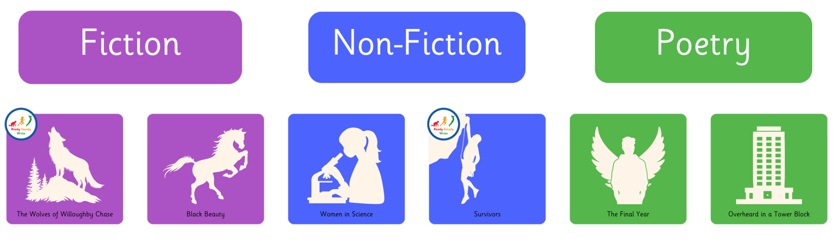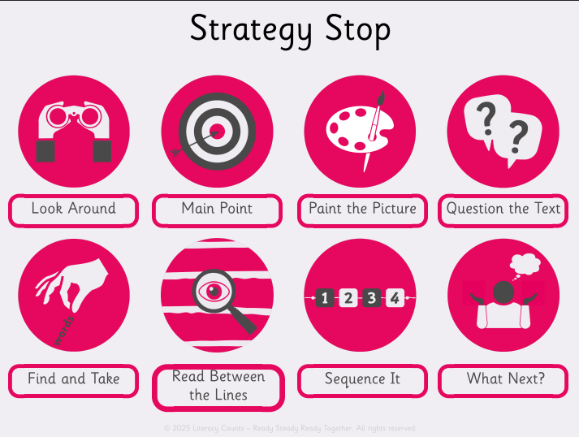

P.E: Football and Gymnastics
- To apply their prior learning of passing, dribbling, turning and moving, to move the ball up the pitch, creating an attack that results in a successful shot.
- Refine knowledge and understanding of defending and how different tactics can be applied during a game to prevent attacking opportunities.
- The focus of the learning is to continue to challenge pupils' creativity as they use and apply their understanding of the different themes
DT: Structure Playground
- Create five apparatus designs, applying the design criteria to their work.
- Make suitable changes to their work after peer evaluation.
- Make roughly three different structures from their plans using the materials available.
- Complete their structures, improving the quality of their rough versions and applying some cladding to a few areas.
- Secure their apparatus to a base.
- Make a range of landscape features using a variety of materials, which will enhance their apparatus.

