

Mayville Academy

Reading Policy

Approved by: |  | Date: 07/10/25
Last reviewed on: | 07/10/25
Next review due by: | 07/10/27

Mayville Academy Reading Policy

Contents
- Our Vision for Reading
- Aims of Reading
- Phonics at Mayville Academy
  - Read Write Inc. (RWI)
  - Phonics in EYFS
  - Phonics in Key Stage 1 and 2
  - Phonics Screening Check
- Progression in Reading
  - From Early Years to Key Stage 2
- Whole-Class Reading: Ready Steady Read Together
  - Programme Overview
  - Key Skills and Focus Areas
  - Progression and Sequencing
- Assessment of Reading
  - Reading Fluency and Book Banding
  - Reading Comprehension
  - Use of Data
- Inclusion and Access for All
  - Support for EAL, SEND and targeted readers
  - Inclusive and diverse texts
- Reading for Pleasure
  - Daily Reading Time and Story Time
  - Library Visits
  - Reading Gladiators
  - Reading Corners
  - Author Visits and Events
- Monitoring and Evaluation
  - Role of the Reading Lead
  - Review and Improvement
- Resources and Interventions
  - Classroom Resources
  - Targeted Support Programmes
- Parent Guide: Supporting Reading at Home
  - Daily Reading Tips
  - Talking About Books
  - Reading Environment
  - Getting Involved



At Mayville Academy, we are committed to developing confident, fluent, and enthusiastic readers who read for both pleasure and purpose. Our reading curriculum is built on the National Curriculum for English (2014) and delivered through a consistent, whole-school approach.
We use Read Write Inc. (RWI) to provide high-quality phonics teaching, ensuring that children develop secure early reading and decoding skills. From Key Stage 1 onwards, we deliver reading comprehension through Ready Steady Read Together — a structured, whole-class programme from Literacy Counts. This approach uses high-quality, diverse texts and metacognitive strategies to deepen understanding, enhance vocabulary, and promote a love of reading.

Our aim is to ensure that every child, regardless of background or ability, has the opportunity to achieve success in reading. Through engaging teaching, inclusive practice, and a shared passion for books, Mayville Academy seeks to nurture lifelong readers who can access and enjoy the world through words.
Aims of Reading
At Mayville Academy, we believe that reading is central to every child’s learning and personal development. We aim to nurture a love of reading, develop confidence and competence, and equip pupils with the skills to access and understand a wide range of texts across different contexts.
Our objectives are for all pupils to:
- Develop a positive attitude towards reading and English, and take pride in their achievements.
- Build self-confidence and work independently, cooperatively, and with perseverance.
- Communicate ideas clearly and fluently, listening effectively and sharing experiences appropriately.
- Experience a sense of achievement, applying knowledge and skills to new situations.
- Read fluently, accurately, and with understanding, using strategies such as skimming and scanning.
- Become independent, reflective, and critical readers, able to select, interpret, and evaluate information from a wide range of sources including print, media, and digital texts.
- Recognise the importance of literacy beyond the classroom and have equal opportunities to access all reading experiences, regardless of ability, race, or gender.
This policy ensures that every child develops the skills and confidence to read for learning, pleasure, and lifelong communication.


Our Phonics Programme
At Mayville Academy, early reading is taught through Read Write Inc. (RWI), a systematic synthetic phonics programme. Consistent implementation of a single scheme ensures fidelity, continuity, and effectiveness in the teaching of early reading across all phases.
All staff in the Early Years Foundation Stage (EYFS), Key Stage 1, and Key Stage 2 are trained in the delivery of RWI and receive regular professional development to maintain high standards of practice.
- Daily phonics sessions are delivered in Reception and Year 1 for approximately 40 minutes.
- Pupils are grouped according to ability and formally assessed at the end of each half term to monitor progress and inform planning.
- Ongoing assessments throughout the term ensure teaching remains responsive to pupils’ individual needs.
- Pupils receive daily phonics homework and take home RWI reading books weekly to consolidate their learning and promote reading fluency.
In preparation for the Year 1 Phonics Screening Check, additional targeted support is provided through mentoring and intervention sessions. Pupils in Year 2 who did not meet the expected standard in the previous year’s check continue to receive phonics instruction until all sounds are secure.
EYFS Phonics
In the Early Years Foundation Stage (EYFS), phonics is introduced through the Read Write Inc. (RWI) programme. Both Nursery and Reception children engage in daily phonics sessions that build foundational skills in sound recognition, blending, and segmenting.
Nursery children begin by developing phonological awareness through interactive, play-based activities such as rhymes, songs, and games. As children progress into Reception, phonics teaching becomes more structured and systematic, with sounds introduced progressively in line with the RWI scheme.
Assessments are carried out regularly to ensure pupils are taught at the appropriate level, and groupings are adjusted accordingly. This ensures that all children make rapid and sustained progress in early reading.
Key Stage 1 Phonics
In Key Stage 1, phonics continues to be delivered through the Read Write Inc. programme. Formal assessments are undertaken regularly to monitor progress and inform groupings. Pupils requiring additional support receive targeted intervention from trained teachers and learning support assistants. Groupings are reviewed periodically to close gaps and ensure steady progression.

Phonics Screening Checks
The Year 1 Phonics Screening Check is administered annually during the summer term. Pupils in Year 2 who did not meet the expected standard in the previous year retake the check alongside Year 1 pupils. A mock screening check is conducted in advance to familiarise pupils with the assessment format and build confidence.
Key Stage 2 Phonics
Some pupils in Key Stage 2 may continue to access Read Write Inc. Through the programme Fresh start sessions to reinforce phonics knowledge and strengthen decoding skills. Targeted catch-up and intervention sessions, delivered by trained staff, ensure all pupils achieve fluency, accuracy, and confidence in reading.

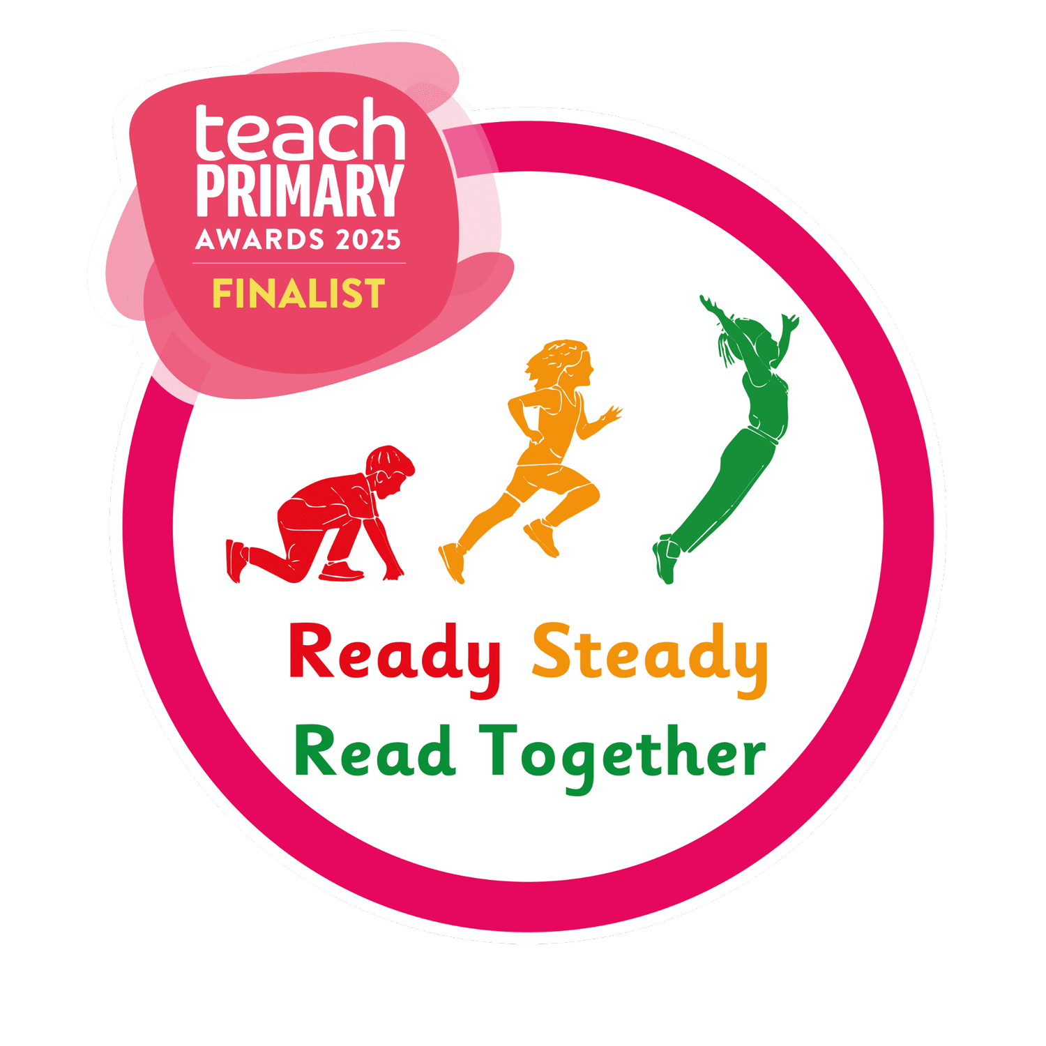


Progression from Early Years
As children move from the Early Years into the next stage of their education, we ensure a smooth and structured progression in reading. The foundation laid in Early Years—through play-based learning, storytelling, and early phonics—is built upon systematically to support each child’s growing literacy skills. Our aim is to develop confident, fluent readers who enjoy reading and are able to understand and engage with a wide range of texts.
Shared Reading Approach – Ready Steady Read Together
As part of our commitment to developing confident, fluent readers with strong comprehension skills, we implement Ready Steady Read Together as our whole-class shared reading programme from Year 2 to Year 6.
This structured, daily programme supports the teaching of reading through fully resourced lessons that explicitly develop metacognitive strategies. Pupils engage with high-quality, diverse texts written by a range of exceptional children’s authors, fostering a love of reading while ensuring progression in comprehension and reading attainment across the key stages.
We use Ready, Steady, Read, a carefully structured reading program, to guide this progression. This program ensures that children develop key skills in a step-by-step manner while maintaining the enjoyment of reading. The main areas of focus include:

- Phonemic Awareness and Phonics: Children consolidate their understanding of sounds (phonemes) and their corresponding letters (graphemes). They learn to segment and blend sounds to read unfamiliar words, moving from simple CVC words (consonant-vowel-consonant) to more complex spelling patterns.
- Decoding and Fluency: As children gain confidence, texts gradually become more challenging. This supports reading fluency—the ability to read smoothly, accurately, and with expression—while reinforcing previously learned phonics and sight words
- Comprehension Skills: Children are guided to understand what they read, make predictions, and discuss ideas and events in the text. They are encouraged to think critically, answer questions, and explain their reasoning, developing deeper understanding and analytical skills.
- Vocabulary Development: Through exposure to a wide range of stories, poems, and informational texts, children expand their vocabulary. Teachers introduce new words in meaningful contexts, helping children to use them in speaking and writing.
- Reading for Pleasure: Ready, Steady, Read promotes a love of reading by providing access to high-quality, engaging texts. Children are encouraged to choose books that interest them, fostering independent reading and a positive reading habit.
- Individualized Support: Teachers continuously assess children’s reading progress. Observations and structured assessments help identify each child’s strengths and areas for support, ensuring tailored interventions where necessary.
By using Ready, Steady, Read, we ensure a consistent and progressive approach to reading that builds on the Early Years foundation. Children move confidently from early decoding and basic comprehension to fluent reading, deeper understanding, and an appreciation of texts across genres. This approach ensures continuity, challenge, and enjoyment, creating enthusiastic readers who are well-prepared for future stages of education.

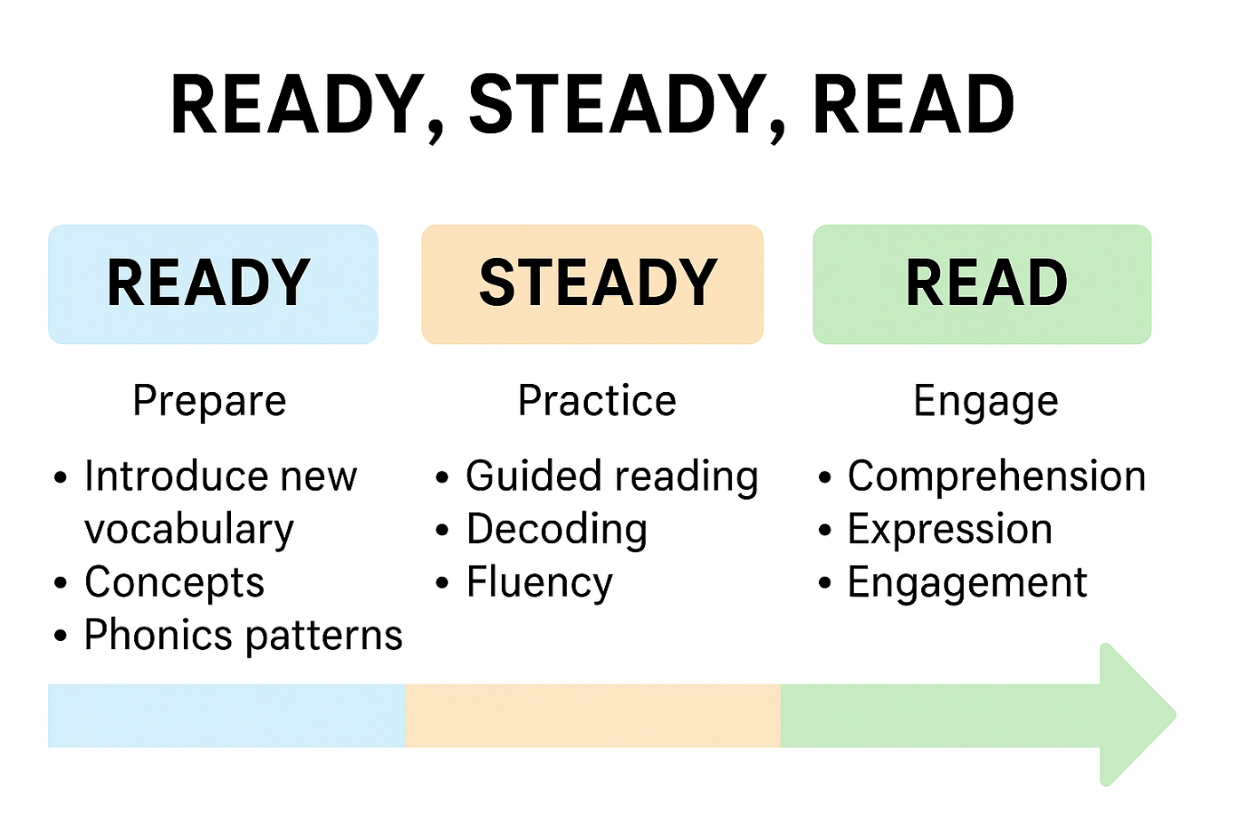Shared Reading Progression: Ready Steady Read Together
As part of our whole-class reading provision, Ready Steady Read Together is delivered daily from Year 2 to Year 6. This structured programme supports the development of key comprehension strategies, vocabulary acquisition, fluency, and oracy through high-quality, diverse texts. The programme is fully aligned with the National Curriculum and is sequenced to ensure clear progression across year groups.
Implementation and Sequencing
- The programme is taught in daily 40-minute lessons, covering a full academic year
- Units are carefully sequenced within and across year groups to build on prior learning and develop increasingly sophisticated reading behaviours.
- Texts are selected to reflect a range of genres, themes, authors, and cultural contexts, increasing in complexity from Year 2 to Year 6.
Each half term, pupils engage with six high-quality reading units that include:
- 2 fiction texts
- 2 non-fiction texts
- 2 poetry texts
This balanced approach ensures wide coverage of genres and text types, exposing children to a diverse range of literary forms, themes, and authors. It also supports more engaging and enjoyable teaching of reading, as it allows teachers and pupils to explore different styles of writing and content across the curriculum.

Reading Focus | Year 2 | Years 3–4 | Years 5–6
Text Complexity | Shorter texts with familiar settings and characters; clear structure | Greater variety of genres; introduction to figurative language and layered narratives | Complex texts including literary heritage, abstract themes, and non-linear structure
Comprehension | Literal retrieval; simple inference; sequencing of events | Justifying inferences with evidence; summarising key points; identifying viewpoint | Comparing authorial choices; analysing bias and purpose; synthesising across texts
Vocabulary Development | Understanding word meanings in context; building core Tier 1 and 2 vocabulary | Use of morphology and context to explore unfamiliar words; expanding Tier 2 vocabulary | Exploring shades of meaning; understanding idiomatic and figurative language; Tier 3 vocabulary linked to subjects
Fluency | Developing accuracy and pace; rereading to support understanding | Increased fluency and expression; improved phrasing and intonation | Confident, expressive reading of complex texts; maintaining understanding over longer passages
Oracy & Discussion | Teacher-led discussion; responding to questions with support | Paired and group discussion; expressing ideas clearly; listening and building on others' views | Leading discussions; debating interpretations; critical discussion of authorial intent

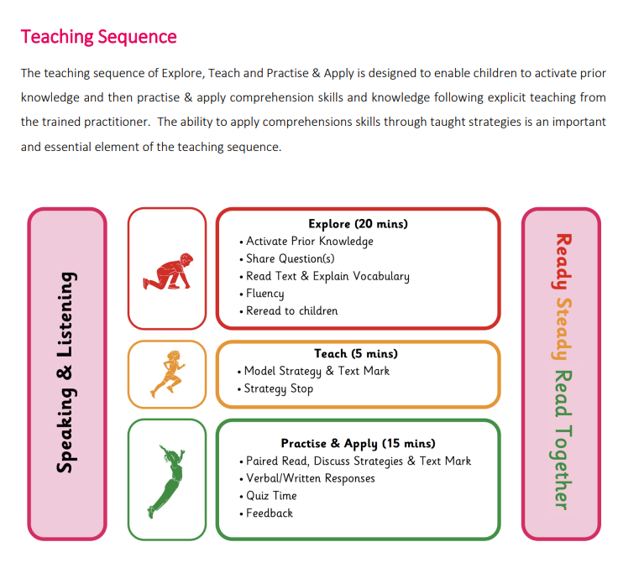
Assessment
Reading Assessment
Children’s reading progress is assessed regularly, and pupils are placed on appropriate book bands.
- In Key Stage 1, children receive one banded book and one additional unbanded book to enjoy at home each week. Children all have a reading record that should be signed by parent/carer weekly.
- In Key Stage 2, children take home a reading book of their choice. Reading records are checked daily. Children all have a reading record that should be signed by parent/carer daily.
- Formal reading assessments are conducted half termly.
- In Years 6 assessment occurs more frequently in preparation for SATs.
Reading Comprehension Assessment
Teachers assess reading comprehension through formative and summative methods.
- Formative assessment takes place daily, helping teachers adapt planning and respond to pupil needs.
- Summative assessments are used termly to evaluate progress against curriculum objectives.
- Teachers track pupil progress using tick sheets aligned to National Curriculum objectives, kept in reading comprehension books.

Assessment data is uploaded to Sonar each half term. Outcomes inform planning, pupil progress meetings, and parent discussions. Pupils also complete statutory national reading assessments at the end of Year 2 (optional) and Year 6 (compulsory)

Inclusion and Access
- Texts are chosen with representation and inclusion in mind, ensuring that all pupils see themselves reflected in the literature they read.
- Support strategies, such as scaffolding, vocabulary pre-teaching, and small group discussion, are used to ensure all learners, including EAL and SEND pupils, can access and benefit from the programme.

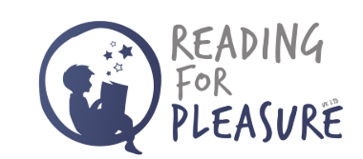
Reading for Pleasure
At Mayville Academy, we are committed to creating a reading culture where every child develops a lifelong love of books. We believe that reading for pleasure is a key driver of academic success, emotional wellbeing, and creativity. As such, we have embedded a range of opportunities throughout the school day and wider school life to nurture and celebrate the joy of reading.
Key Features of Our Reading for Pleasure Provision:
- Daily Dedicated Reading for Pleasure Time
Every class has a daily slot dedicated to reading for pleasure. During this time, pupils are encouraged to choose books that interest and excite them, promoting independence and ownership of their reading journey.
- Daily Story Time
All classes enjoy daily story time, where teachers read aloud high-quality texts. This shared experience builds listening comprehension, vocabulary, and emotional engagement with stories.
- Regular Library Visits
Pupils have regular access to the school library, where they can explore a wide range of books. Our library is stocked with age-appropriate, diverse, and engaging texts that reflect pupils’ interests and broaden their reading horizons.
- Gladiators Reading Groups
For pupils who require stretch and challenge, we run Reading Gladiators groups. These sessions provide high-level discussion and analysis of rich, thought-provoking texts, enabling deeper engagement and critical thinking.
- Inviting Reading Environments
All classrooms feature well-designed reading corners that are inviting and comfortable. These spaces are equipped with carefully selected books that are attractive, current, and specifically chosen for each year group.
- Promoting a Reading Culture
We work hard to foster a reading-rich environment across the whole school. Displays celebrate books and authors, staff share their own reading recommendations, and we encourage book talk among pupils and staff.
- Author Visits and Book Events
We regularly invite children’s authors into school to inspire and excite pupils about reading and writing. These visits give pupils the opportunity to meet real writers, ask questions, and see reading as a vibrant, real-world activity.

Monitoring and Evaluation
Monitoring the standards of children’s work and the quality of reading teaching is the responsibility of the Reading Lead. This role includes:
- Supporting colleagues in the effective teaching of reading
- Keeping up to date with current developments in reading education
- Providing strategic leadership and direction for reading across the school
The Reading Lead meets regularly with the Headteacher and provides termly summary reports to Trustees. These reports evaluate strengths and areas for development in reading and outline actions for further improvement.
Allocated leadership time enables the Reading Lead to:
- Review samples of pupils’ work
- Conduct lesson observations
- Monitor reading provision and progression across the school
Resources
A wide range of resources supports high-quality reading provision across the school:
- Classrooms are equipped with dictionaries, thesauruses, and vocabulary mats
- Learning environments are literacy-rich and include creative, well-stocked book corners
- Class libraries include a range of fiction and non-fiction texts
- Pupils have regular access to the school library
For children who require additional support, interventions include:
- Nessy (an online reading intervention programme used in KS1 and KS2)
- IDL – a literacy intervention which is computer based. It is multi-sensory system which supports children with literacy based learning difficulties to increase their reading and spelling ages.
All intervention books are banded to ensure they meet pupils’ individual reading levels and support progression.
📚 Supporting Your Child’s Reading at Home
A Parent Guide from Mayville Academy
At Mayville Academy, we believe that when schools and families work together, children become confident, successful readers. Here’s how you can support your child’s reading at home — in ways that are simple, effective, and enjoyable for the whole family.
💬 Read Together Every Day
Reading little and often makes a big difference. We recommend 10–15 minutes of reading every day.
- Key Stage 1 (Years 1–2): Read aloud to your child, listen to them read, or enjoy a book together.
- Key Stage 2 (Years 3–6): Encourage independent reading, and ask your child to read aloud sometimes. Still read to them too — older children love stories just as much!
✅ Don’t worry if your child wants to read the same book again — re-reading builds confidence and fluency.
🗣️ Talk About Books
Talking about what your child is reading helps them understand and enjoy it more.
Try asking:
- What was your favourite part of the story?
- What do you think will happen next?
- Would you recommend this book to a friend? Why or why not?
📖 Use the Reading Record
Please sign your child’s reading record each time they read at home. Feel free to leave a short comment about how they got on — this helps us support them in school too.
🛋️ Create a Reading-Friendly Space
- Find a quiet, cosy place at home where your child can enjoy books with minimal distractions.
- Keep books, comics, or magazines nearby — anything that encourages reading counts!
🌟 Be a Reading Role Model
Children who see adults reading are more likely to read themselves. Show them that reading is fun and important by:
- Reading your own book, magazine, or newspaper
- Talking about your favourite stories or authors
- Visiting the library together

📚 Books to Take Home
Your child will bring home:
- A banded book matched to their reading level
- A second “reading for pleasure” book to enjoy with the family

📅 Get Involved
- Come along to reading events, parent workshops, and author visits
- Help your child choose exciting new books from the school or local library
- Ask your child about what they’re reading in class
👩‍🏫 Need More Help or Book Suggestions?
Speak to your child’s class teacher or our Reading Lead. We’re always happy to recommend books or talk about how you can support reading at home.
Together, we can help your child build a lifelong love of reading.
Thank you for your support!

