Mayville Academy



Adrenaline Auto-Injectors (AAI) POLICY

(Current brands available in the UK are EpiPen, Emerade, Jext)

A POLICY OUTLINING THE SCHOOL’S UNDERSTANDING OF ITS DUTIES IN THIS AREA OF SAFEGUARDING & WELL-BEING OF PUPILS

Mayville Academy
Adrenaline Auto-Injector (AAI) Policy
“At Mayville Academy, we have due regard for our duties under the Equality Act 2010. This ‘Adrenaline Auto-Injector (AAI) Policy’ reflects our duties to: eliminate discrimination, advance equality of opportunity and foster good relations.”

Policy Statement
Mayville Academy seeks to provide a safe environment for staff and pupils who are at risk of severe allergic reactions. It undertakes to ensure that anyone suffering a severe allergic reaction will be treated appropriately and enabled to access emergency services promptly.

This AAI policy has been drafted in light of recommendations from the Department for Education about the additional purchase of a school based AAI and the administration of the AAI in an emergency.

The school has 4 x AAI devices (EpiPens) of its own:
2 x Adrenaline Auto Injectors (0.15mg) for children aged 6 and under
2 x Adrenaline Auto- Injectors (0.3mg) for children age 6-12 years.
They are stored in the medical room. They are to be used only in an emergency when a pupil suffers a potential allergic reaction and does not have their own AAI (EpiPen) to hand.

Parents have been made aware of the school based AAI’s and the school has a register list of those who have given consent for them to be used in the event of an emergency.

Protocol
Anaphylaxis is a severe systemic allergic reaction. At the extreme end of the allergic spectrum, the whole body is affected usually within minutes of exposure to the allergen. It can take seconds or several hours.

Anaphylaxis involves one or both of two features:
  - Respiratory difficulty (swelling of the airway or asthma)
  - Hypotension (fainting, collapse or unconsciousness)

The symptoms are:
- Persistent cough
- Hoarse voice
- Difficulty in swallowing or speaking, swollen tongue
- Alterations in the heart rate
- Hives anywhere on the body
- Abdominal cramps and nausea
- Sudden feeling of weakness
- Difficulty or noisy breathing
- Wheezing
- Persistent dizziness
- Becoming pale or floppy
- Suddenly sleepy, collapse, unconsciousness.

Please refer to the protocol for emergency for an allergic reaction on page 4 of this policy.

Procedure
- The medical histories of all new pupils are carefully searched to identify possible cases of allergy sufferers. Any medical questionnaires not returned are to be vigorously pursued. Staff are aware of pupils who may require an AAI and their photo and medical information is published on the medical information sheets. The staff and school’s first aiders are all aware of these pupils.
- As a school, we ensure that the presence in school of a susceptible pupil is made aware to all those who need to know. Children are identified by photographs displayed on the medical notice boards in the staff room, in the child’s class register, in the school kitchen as well as in the school’s main office.
- If a particular allergen is identified eg. Peanuts, consideration should be made to ask the Harrison staff to avoid this ingredient. Parents are advised that it is their responsibility to complete the Harrison Special Diet/Allergy Form giving the details of the allergy so that the caterers can make an assessment and liaise with the parent. This form is available on our school website: http://www.mayville.waltham.sch.uk
- It should be noted that Mayville Primary is not a “nut free” Academy.
- Adrenaline Auto-Injectors (AAI) are stored in a clearly labeled box on a shelf in the medical room.
- A written protocol for treatment of anaphylaxis is kept with each AAI.
- Parents are responsible for checking the AAI expiry dates regularly. This is followed up on a termly basis by the school office.
- Children who have been prescribed an AAI know where to access them at all times. The school does have its own spare AAI and they are kept in a clearly labeled box on a shelf in the medical room

Use of Adrenaline Auto-Injector in School
As a school, we recognize an AAI should only be administered to children to whom it has been prescribed. This should be by a person who has received training and feels competent to use the device. In the event of an emergency, another member of staff may administer the AAI under the guidance of 999 support.

If a child is suspected of having an anaphylactic reaction for the first time the Emergency Services should be called immediately (999/112). The operator will tell you how to manage the casualty while you wait for the ambulance.

Staff receive Anaphylaxis Training annually led by either a member of the School Nurse Team or external agencies

Mayville Academy

PROTOCOL FOR EMERGENCY TREATMENT FOR AN ALLERGIC REACTION
ASSESS THE SITUATION – ACT PROMPTLY
Send someone to the location of the AAI, e.g. the medical room
The child may also need their inhaler

SEVERE REACTION
Wheezy, difficulty breathing, coughing, choking Difficulty speaking
Pale, sweaty, floppy
A rash may also be present
The child may collapse/become unconscious

Ask someone to CALL 999 FOR AN AMBULANCE stating possible anaphylactic shock

ADMINISTER EPIPEN (reference www.epipen.co.uk)
- Grasp Epipen in dominate hand (the hand you write with), with thumb nearest blue safety cap and form fist around unit (orange tip down)
- With other hand, pull off blue safety cap
- Hold Epipen approximately 10cm away from the outer thigh. The orange tip should point towards the thigh.
Jab the EpiPen firmly into outer thigh at a right angle (90 degree angle) (listen for click). EpiPen can be injected through clothing. Check that orange end will not hit buckles, zips, buttons or thick seams on an individual’s clothes.
- Hold in place for 10 seconds.
- Epipen should be removed and handed to team taking over management of patient
- Massage injection site for 10 seconds.
- Patient must go to A&E as relapse can occur within a few hours and/or further management may be required.
- Each Epipen can only be used once. If symptoms don’t improve, administer a second EpiPen after 5-15 minutes.
- If conscious, lay child on the floor with legs elevated
- Sit the pupil up if breathing is difficult.
- If unconscious, place in recovery position to maintain airway
- Stay with child until further help arrives.
IF CONDITION DETERIORATES AND THE CHILD STOPS BREATHING BEGIN RESUSCITATION (CPR)

Mayville Academy Guide to Using An EpiPen® and Trainer Pen - Simple Steps
- Using an EpiPen® is easy, especially if you practise using the Trainer Pen. Staff should familiarise themselves with these simple steps so that they are clear about what to do in an emergency.

- There is no need to remove clothing to use an EpiPen®, but make sure the orange end will not hit buckles, zips, buttons or thick seams on an individual’s clothes.

- To remove EpiPen® from the carry case. Flip open the lid on the carry case. Tip the carry case and slide the EpiPen® out of the carry case.

- Lie the individual down with the legs slightly elevated to keep the blood flowing or sit the individual up if breathing is difficult.
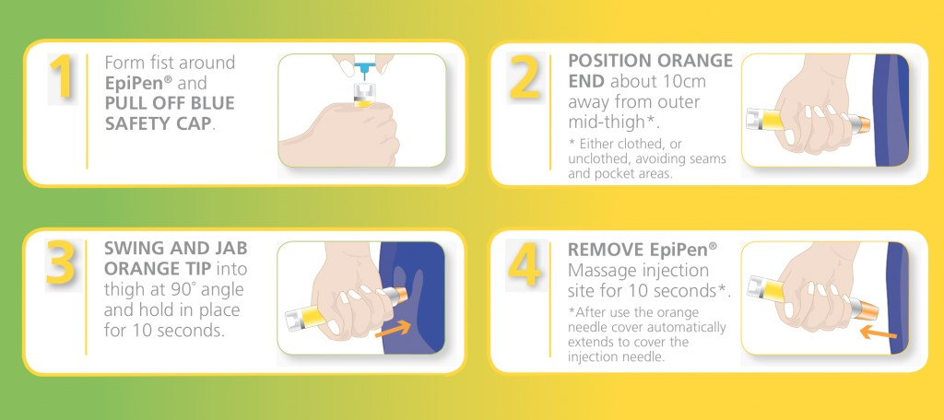
- Each EpiPen® can only be used once. If symptoms don’t improve, you can administer a second EpiPen® after 5-15 minutes.

Points to Note in the Event of an Emergency
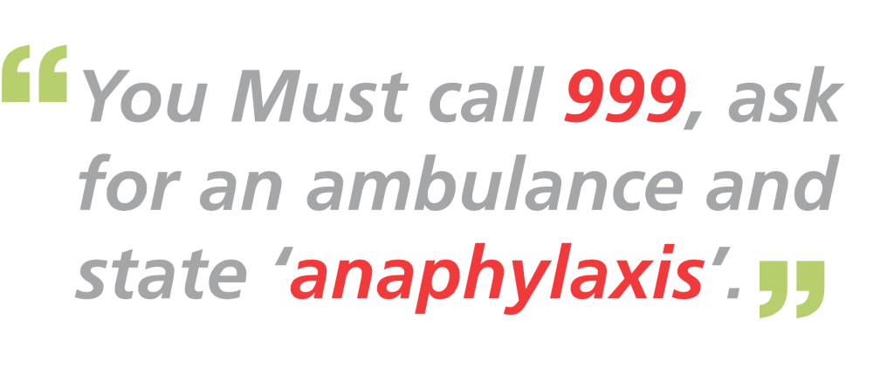
- Ensure the individual stays lying down or seated and have someone stay with the individual until they have been assessed by a paramedic.

- Unconscious patients should be placed in the recovery position.
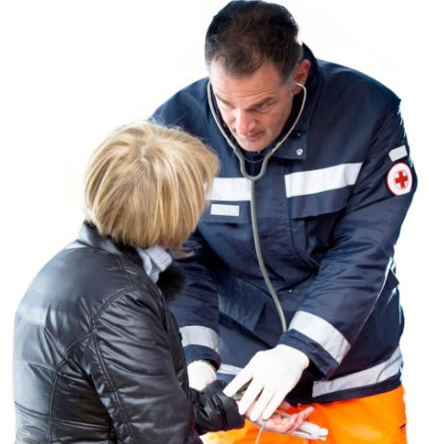

To reset the EpiPen® Trainer Pen

1. Replace the blue safety cap.
2. Place the orange tip on a hard surface, squeeze the sides of the orange tip and push down.

