Geography:
Where do I live?
- To be able to name the seven continents of the world and locate the UK on a world map.
- To be able to identify the countries and capital cities where you live.
- To be able to identify features and characteristics of the countries in the UK.
- To explore the town we live in.
- To be able to describe where you live.
Maths

Number formation

Place Values

- To learn about how to sort, count and represent objects.
- To count, read and write numbers forwards and backwards up to 10.
- To learn how to compare, order numbers and groups.
- To learn how to use a number line.

- Addition and Subtraction (within 10)
- To learn the part whole model.
- To learn about number facts and the addition symbol.
- To learn about adding and subtraction one digit numbers.
- To learn the correct vocabulary for addition and subtraction.
Science: Human Body

- To identify and label parts of the human body.
- To understand how we see.
- To understand how we hear.
- To understand how we taste.
- To understand how touch works.
- To understand how we smell.

Computing: Improving Mouse skills
I will be able to:
- Log on
- Click and drag
- Draw shapes
- Draw a story
- Create a Self portrait


Guided Reading
- Set 1 and Set 2 sounds introduced.
English:
AF1 Use a range of strategies including accurate decoding of text, to read for meaning.
AF2 Understand, describe, select or retrieve information, events or ideas from texts and use quotation and reference to text.

Fiction: The Queens Hat Short narrative retell the story
- Letter formation
- Capital letters
- Full stops
- Finger spaces
- Adjectives
- Nouns

Autumn 1
This term our topic is on: Where do I live?
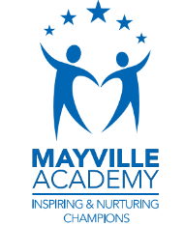
Music:
Pulse and rhythm: (Theme: All about me)
- To use my voice and hands to make music
- To clap and play in time with the music.
- To play simple rhythms on an instrument
- To listen to and repeat short rhythmic patterns
- To understand the difference between pulse and rhythm

R.E: Christianity
Theme: ‘Creation Story’
Key Question: Does God want Christians to look after the world?
To understand how the world was created
To understand who created the wold in Christianity
To investigate the importance of how to look after the world

PSHE: 1 Decision-Feelings and Emotions

- To understand a range of emotions and how they make us feel physically and mentally.
- To be able to recognise and name emotions and their physical effects.
- To know the difference between pleasant and unpleasant emotions. (Jealousy)
- To learn a range of skills for coping with unpleasant/uncomfortable emotions.
- To identify different Golden rules
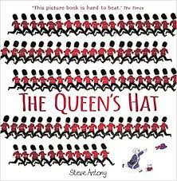

Art- Painting-Inspirational Artist-Linchestein
- Focus on inspirational artist, observe artwork and discuss techniques. Explore feelings, thoughts and emotions.
- Explore techniques using inspirations art work and develop a sketch and painting ( techniques: tints, colours, textures, shades and tones)
- Critique and up level- Explore techniques using inspirations art work and develop the sketch with the focus form of media (techniques: mixing patches, colour tone and trialling on different types of paper)
- Master techniques- Creating their own version taking inspiration from the Artist.
- Evaluate techniques and compare own work with inspirational artist work.

PE – Loco Motion-Running & learning through play
- Understanding the principles of attack
- Defence Applying attacking/ Defending principles into a game Consolidate attacking/defending
- Health and well being
- Team building

