
Friday 9th May 2025
Head Teacher Message
Dear parents and Carers,
Year 6 SATs
It’s SATs week next week from Monday-Thursday. Our Year 6s have worked extremely hard. They have shown a very determined attitude, consistently attending both interventions and Saturday school. The Year 6 teaching team have dedicated their time and effort to ensure the children are prepped and ready. I expect that with all of their hard work they will all do well.
Good Luck Year 6 super proud of you!!!!
Please remember our Year 6s can attend breakfast club free of charge next week
New uniform and Logo
We have some exciting news to tell our Mayville families. In October of this year we created a working party to look at refining our vision and values, part of this process was also considering revamping our logo and a name change.
We continued to work on this throughout the year and are pleased to announce that from September we will be called ‘Mayville Academy’ and have a brand new logo to match. As of September parents will be able to buy the new uniform. As well as jumpers you can also purchase the logoed P.E t-shirt, fleece and book bag. Thank you to all of the Mayville team including Trustees, staff and school council who made the vision come to life with all of their amazing contributions.
Time to say ‘Good Bye’
It’s with great sadness that we have to say goodbye to our Early Years lead Ms Elysia Trevino. In the short time Elysia has been with us she has made an amazing impact on our Nursery. The care and consideration she gives the children and families is one of her many special attributes.
Ms Trevino will be returning to Switzerland with her husband and although she will definitely be missed by all. I know all of the Mayville family would like to wish her well and safe travels.
For the rest of the summer term Ms Natalie, Ms Tahir and Ms Soumaya will continue to run the nursery with Ms Natalie leading. I’m sure that your children will be pleased to have their familiar faces, which will reassure the children and guarantee the transition is smooth.

Goodbye from Ms Elysia
Dear Early Years Parents and Carers,
I hope this message finds you well. I’m writing to let you know that after the upcoming half-term break, I will be leaving my position as Nursery Teacher at Mayville Primary. My husband and I will be moving back to Switzerland due to his work, and although this is an exciting new chapter for our family, it is a bittersweet moment for me personally.
It has been a true privilege to teach your children over the past two years. Watching them grow, learn, and develop has brought me so much joy, and I will treasure the memories we’ve made together. It’s not easy to say goodbye, and I will miss each and every one of them dearly.
I’m pleased to let you know that Ms. Natalie will be taking over as the Nursery Teacher in my absence. She has been working alongside the children throughout this year and already has a strong bond with them. I am confident that she will continue to provide a nurturing and inspiring learning environment for your little ones.
Thank you for all your support during my time at Mayville. It has been a truly special chapter in my teaching journey.
With warmest wishes,
Elysia Trevino
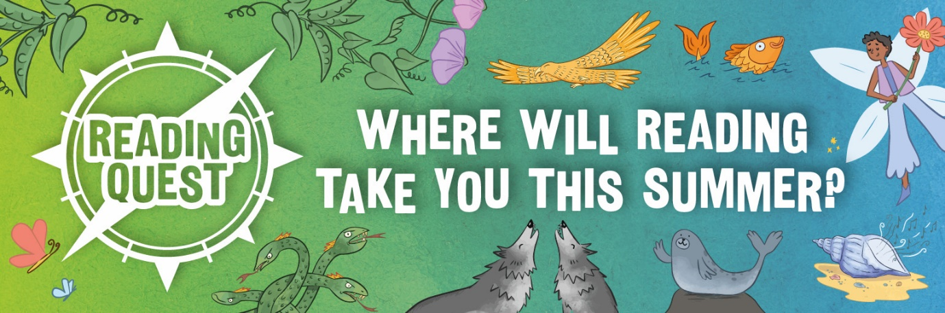
Summer Reading Programme
As you know reading is a key priority at Mayville. The benefits of learning to reading at a young age ensures a child is ready for everything. Reading is a tool that opens them up to the wonders of the world. As part of our reading goals we would like to promote reading for pleasure across the school.
This term we launch the ‘Summer reading programme’. Your child will be reading the book in class and then tasked with completing the activity at home. This is voluntary so feel no pressure to complete but the more activities your child completes the more chances of being a prize winner.
Let the reading begin!!!!!!!

Ms Sharon Parson (Head teacher)
Have a Great weekend!!

Summer Term Dates for your Diary

Event | Date | Time
Summer Reading Programme | 12th May -19th July | -
VE Day workshops-Y3, 4 and 5 | 12th May 2025 | 9.00am-12.00pm
Year 3 at London Zoo | 13th May 2025 | All day
Year 6 SATs week | 12th May-16th May 2025 | Mornings
Walk to School week | 19th May-23rd May 2025 | Mornings
Induction day for new Reception Parents | 20th May 2025 | Morning
Half Term | 26th-30th May 2025

Mayville Virtues
Autumn  Kindness | Spring  Respect | Summer  Determination

Language of the Month
Albanian
Hello -Ckemi

Word of the Month
‘Responsibility’
Meaning –State of being accountable.


Rights Respecting
Article 12
‘Every child has the right to express their views, feelings and wishes in all matters affecting them, and to have their views considered and taken seriously’.
KS2 Celebration Assembly
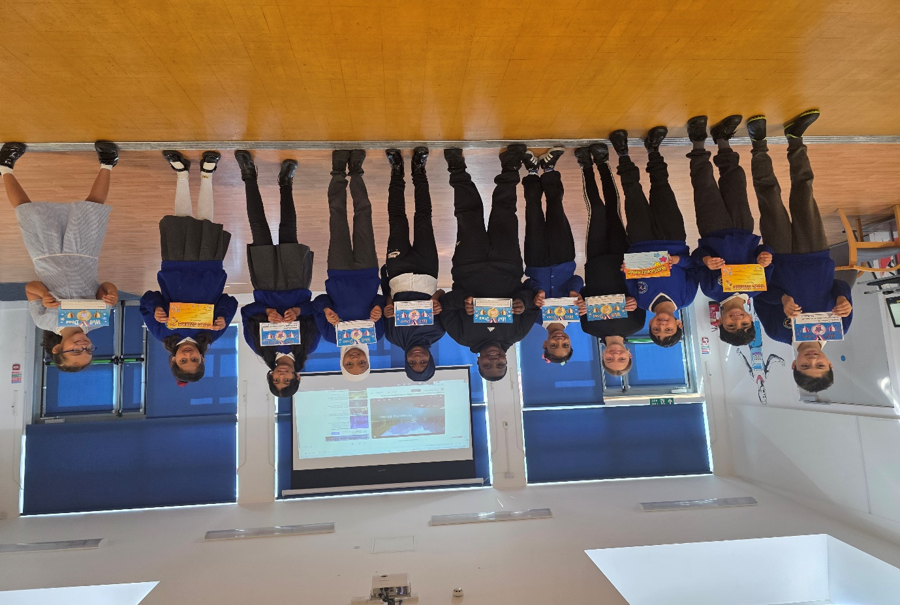
Our Amazing children exhibiting the virtue of ‘Determination’ Well done!!! Super proud of you.

